Zizek
Table of Contents 1
Strategy Guide 3
Nature’s Fantasy 1nc Shell 4
1nc 5
1nc 6
1nc 7
1nc 8
1nc 9
1nc 10
1nc 11
1nc 12
1nc 13
1nc 14
1nc 15
***Links 16
Environmental Harmony Link 17
Anthropocentrism 18
Anthropocentrism cont. 19
Enviro Managerialism Link/Impact 20
Technological Thought Link 21
Catastrophe Imagery Link 22
Catastrophe Imagery Link 23
Exclusion Link 24
Identity Ptix 25
Multiculturalism Link 26
Law Link 27
Modern Science Link 28
***Impacts 29
Ideology is the root cause of Environmental problems 30
Turns Case 31
Turns Case cont. 32
No Solvency 33
Scapegoating 34
Scapegoating/Holocaust 35
Holocaust (Really good rhetoric) 36
Ideology Stifles Environmental Policy 37
***Alternative 38
Traverse the Fantasy of Natural Control 39
Reject the Fantasy 40
***Answers To Section 41
A2 Perm 42
A2 Perm 43
A2 Alt doesn’t solve/ It’s impossible/ Cap inevitable 44
A2 Alt Doesn’t Solve 45
A2 Link Turn 46
A2 Revolution→ Totalitarianism 47
A2 Case outweighs 48
A2 Case Outweighs 49
Framework 50
A2 Zizek is Tautological 51
A2 Robinson 52
A2 Robinson 53
A2 Robinson 54
***Affirmative Answers 55
Perm 56
Perm 57
Perm 58
Perm-Small Demands 59
Ideological Control Inevitable 60
Resistance → Violence 61
Law Negates the Law 62
Alt doesn’t Solve 63
Alt doesn’t Solve cont. 64
Alt Doesn’t Solve 65
Alt Doesn’t Solve Cont. 66
Zizek Indict 67
Zizek Indict 68
Zizek Indict 69
Fantasy Offense 70
No Fantasy 71
Robinson 72
Robinson 73
Robinson 74
Robinson and Tormey 75
Robinson and Tormey 76
Robinson and Tormey 77
Robinson and Tormey 78
Robinson and Tormey 79
A2 Robinson Groups Lacanians 80
A2 Grouping of Lacanian Authors 81

Strategy Guide
Ok, so this is your basic Zizekian criticism of ideology. The file is pretty small (a fact that I’m very disappointed in).
Enjoy the jouissance, you silly Slovenians.

“A man who believes himself to be a grain of seed is taken to the mental institution where the doctors do their best to finally convince him that he is not a grain but a man; however, when he is cured (convinced that he is not a grain of seed but a man) and allowed to leave the hospital, he immediately comes back very trembling of scare - there is a chicken outside the door and that he is afraid that it would eat him. "Dear fellow," says his doctor, "you know very well that you are not a grain of seed but a man". "Of course I know that," replies the patient, "but does the chicken know it?"”

Quick and Dirty Definition of Terms:

Real- opposite to the imaginary and beyond the Symbolic. It is the area of the human psyche where is there is no gap in signification or inability to signify/
Lack- The inability to signify in the Symbolic Order.
Fantasy- a situation imagined by an individual or group, which does not correspond with reality but expresses certain desires or aims of its creator
Jouissance- excess enjoyment, usually some sort of sexual connotation.
Symbolic order- the linguistic dimension of the psyche
Big other- located in the Symbolic order, it is usually viewed as the Law and in Zizekian writings is usually talking about Capitalism.

There’s a bunch of literature I recommend to beef up this file:

1. The Ticklish Subject: Everything After Chapter 1 (By Zizek)
2. Conversations with Zizek (By Zizek)
3. Zizek’s Ontology- a 2008 book by Adrian Johnston
4. In Defense of Lost Causes (By Zizek)
5. YANNIS STAVRAKAKIS, DEPARTMENT [“ON THE EMERGENCE OF GREEN IDEOLOGY: THE DISLOCATION FACTOR IN GREEN POLITICS,” DISCOURSE THEORY AND POLITICAL ANALYSIS] A chapter in a 2000 book

Nature’s Fantasy 1nc Shell
THE STATUS QUO IS NOT AN OBSTACLE PREVENTING THE AFF PLAN, RATHER THE ATTEMPT TO SOLVE THE SYMBOLIC REALITY OF NATURE AND ENERGY IS A FANTASY. INHERENTLY, THE REAL FALLS SHORT OF THE AFFIRMATIVES’S VISION.

Zizek, Professor at the University of Ljublijana and general badass, 2004 (Slavoj, Conversations with Zizek Polity Press(78-9),

Here I would agree with Laclau and Mouffe's notion that society doesn't exist: that there is no neutral space, no neutral reality that can be first objectively described and from which, we then develop the idea of antagonism. Again, this would,: be my idea of fantasy as constituting reality. Of course Nazi, are a real obstacle, but the question is, why are they a real obstacle? The answer is, because they are sustained by a certain fantasmatic universe. That is to say that of course you can describe the way Nazis are a real threat, how they threaten social reality for Jews, but the reason they are a threat in reality has to do with fantasies about radical antagonism. In this sense, the only thing I am claiming is that you cannot account for antagonism as Real in the terms of just : reflection or an effect of some conflicts in social reality. To return to the notion of real Real and reality, the crucial point to bear in mind is that, again, the Lacanian Real is not some kind of a hard kernel: the true reality as opposed to only our symbolic fictions. This is why the notion of the imaginary Real, which I evoked before, is so important. I think that the Real is in a way a fiction; Real is not some kind of raw nature which is then symbolized. You symbolize, nature, but in order to symbolize nature, in this very symbolization, you produce an excess or a lack symmetrically and that's the Real. This is the crucial Lacanian lesson. It - not, as it is sometimes misrepresented, that you have - let • call it naively pre-symbolic reality: you symbolize it and then something cannot be symbolized and that is the Real. No this is just a kind of stupid reality; we don't even have x-. ontological name for it. It is, rather, that the very gesture which symbolization introduces a gap in reality. It is this gap which is the Real and every positive form of this gap is constituted,: through fantasy. So again the crucial thing is to avoid any reification of the, Real. The Real can be considered almost as a topological term, a topological twist, and any substantialization of the, Real is a kind of a perspective-illusion. Real is a purely topological category. With reference to the passage from special to general theory of relativity in Einstein, one could put it in these terms: through symbolization space itself is curved, and the Real is the illusion that this curvature of the space is caused by some positive entity. But the whole point about the Real is that the impossibility is not the result of some positive obstacle, but is purely inherent: the impossibility is produced as the very condition of symbolic space. That is the ultimate paradox of the Real You cannot have it all, not because there is something opposing you, but because of this purely formal, structurally inherent, self-blockade.

1nc
THE TRICK OF IDEOLOGY IS DISTANCE; IN ORDER TO SUSTAIN THE FANTASY, IT MUST REMAIN A DREAM. THE IDEAL OF THE AFFIRMATIVE PREVENTS US FROM MAKING ANY PROGRESS TO SOLVE THEIR HARMS BECAUSE THOSE WOULD REQUIRE TRAUMATIC FAR-REACHING CHANGE, NOT SMALL REFORMS LIKE THE PLAN.

Zizek, Professor at the University of Ljublijana and general badass, 2004 (Slavoj, Conversations with Zizek Polity Press, 12-3)

The central issue is one of proximity; of maintaining a critical distance by keeping the Thing in focus (like the image on a screen) but without coming so close that it begins to distort and decompose. A typical example would be that of someone who fantasizes about an ideal object (a sexual partner, promotion, retirement etc.) and when they actually encounter the object, they are confronted with the Real of their fantasy; the object loses its ideality. The (ideological) trick, therefore, is to keep the object at a certain distance in order to sustain the satisfaction derived from the fantasy `if only I had x I could fulfill my dream'. Ideology regulates this fantasmatic distance in order to, as it were, avoid the Real in the impossible: i.e. the traumatic aspects involved in any real (impossible) change. This allows for a more nuanced reading of ideologies. Let us take the case of an international crisis: the so-called `liberation of Kuwait' during the 1990s Gulf conflict. Here the ideological discourse tended to operate along the following lines: `we must achieve the liberation of Kuwait ... while recognizing that any true liberation (i.e. abolishing Kuwait's feudal dynasty and setting up democratic structures) is currently impossible.' And do we not have something similar with the so-called New World Order? Any real (or indeed Real) attempt to establish such an order would inevitably require traumatic far-reaching changes: global democracy based on universal rights, popular participation, the eradication of poverty and social exclusion (etc.) as part of a genuine 'reflexive modernization'. However, what we actually have is the routine invocation of the New World Order in terms of an indefinite ideal that functions precisely as a way of preventing any real movement towards it. In the Kantian terms of the sublime, any convergence with what might be called the Bush-Blair 'axis of Good' would become an unbearable evil. So we have the same type of ideological supplement at work: `we are moving towards a New World Order that will not tolerate the Saddam Husseins of this world ... while recognizing that a true New World Order (one that would be intolerant of all the autocrats, royal families and the corporate dictatorships of global capitalism) is currently/always impossible. ..'. In this way, impossibility loses its innocence and, far from comprising a simple repressed dimension, is rather something that can be seen to function as an implicit-obscene ideological supplement in today's realpolitik.

1nc
ECOLOGICAL CRISIS IS THE NEW OPIUM FOR THE MASSES. NATURE DOES NOT EXIST, RATHER NATURE IS MERELY A FANTASY. WE NEED TO COME TO GRIPS WITH THE FACT THAT OUR ENERGY CRISIS IS GROUNDED IN OUR BEING.

Zizek, Professor at the University of Ljublijana and a general badass, 2008 (Slavoj, “Censorship Today: Violence, or........ Ecology as a New Opium for the Masses, )
No wonder, then, that the by far predominant version of ecology is the ecology of fear, fear of a catastrophe - human-made or natural - that may deeply perturb, destroy even, the human civilization, fear that pushes us to plan measures that would protect our safety. This ecology of fear has all the chances of developing into the predominant form of ideology of global capitalism, a new opium for the masses replacing the declining religion: it takes over the old religion's fundamental function, that of putting on an unquestionable authority which can impose limits. The lesson this ecology is constantly hammering is our finitude: we are not Cartesian subjects extracted from reality, we are finite beings embedded in a bio-sphere which vastly transgresses our horizon. In our exploitation of natural resources, we are borrowing from the future, so one should treat our Earth with respect, as something ultimately Sacred, something that should not be unveiled totally, that should and will forever remain a Mystery, a power we should trust, not dominate. While we cannot gain full mastery over our bio-sphere, it is unfortunately in our power to derail it, to disturb its balance so that it will run amok, swiping us away in the process. This is why, although ecologists are all the time demanding that we change radically our way of life, underlying this demand is its opposite, a deep distrust of change, of development, of progress: every radical change can have the unintended consequence of triggering a catastrophe. It is this distrust which makes ecology the ideal candidate for hegemonic ideology, since it echoes the anti-totalitarian post-political distrust of large collective acts. This distrust unites religious leaders and environmentalists - for both, there is something of a transgression, of entering a prohibited domain, in this idea of creating a new form of life from scratch, from the zero-point. And this brings us back to the notion of ecology as the new opium for the masses; the underlying message is again a deeply conservative one - any change can only be the change for the worst - here is a nice quote from the TIME magazine on this topic: Behind much of the resistance to the notion of synthetic life is the intuition that nature (or God) created the best of possible worlds. Charles Darwin believed that the myriad designs of nature's creations are perfectly honed to do whatever they are meant to do - be it animals that see, hear, sing, swim or fly, or plants that feed on the sun's rays, exuding bright floral colours to attract pollinators. This reference to Darwin is deeply misleading: the ultimate lesson of Darwinism is the exact opposite, namely that nature tinkers and improvises, with great losses and catastrophes accompanying every limited success - is the fact that 90 percent of the human genome is 'junk DNA' with no clear function not the ultimate proof of it? Consequently, the first lesson to be drawn is the one repeatedly made by Stephen Jay Gould: the utter contingency of our existence. There is no Evolution: catastrophes, broken equilibriums, are part of natural history; at numerous points in the past, life could have turned into an entirely different direction. The main source of our energy (oil) is the result of a past catastrophe of unimaginable dimensions. One should thus learn to accept the utter groundlessness of our existence: there is no firm foundation, a place of retreat, on which one can safely count. "Nature doesn't exist": "nature" qua the domain of balanced reproduction, of organic deployment into which humanity intervenes with its hubris, brutally throwing off the rails its circular motion, is man's fantasy; nature is already in itself "second nature," its balance is always secondary, an attempt to negotiate a "habit" that would restore some order after catastrophic interruptions.

1nc
CATASTROPHE IS UNAVOIDABLE. THE TRUE CATASTROPHE IS THE WORLD WAITING MISERABLY WHERE LIFE IS ONE LONG EMERGENCY. Our vision of a post-catastrophic world where we have looked death in the eye retroactively enables us to think differently about the present and our relation to THE CURRENT CATASTROPHE. Only when we do this can we ever retain our value to life.

Zizek, General badass and Professor of Philosophy at the University of Slovenia 2003, (Slavoj, Puppet and the Dwarf, MIT Press p. 159-66)
This, perhaps, is also the most important ethics lesson of the twentieth century: we should abandon all ethical arrogance, and humbly acknowledge how lucky we are to be able to act ethically. Or, to put it in theological terms: far from being opposed, autonomy and grace are intertwined—we are blessed by grace when we are able to act autonomously as ethical agents. And we have to rely on the same mixture of grace and courage when we are facing the prospect of a catastrophe. In his “Two Sources of Morality and Religion,” Henri Bergson describes the strange sensations he experienced on August 4, 1914, when war was declared between France and Germany: “In spite of my turmoil, and although a war, even a victorious one, appeared to me as a catastrophe, I experienced what [William] James spoke about, a feeling of admiration for the facility of the passage from the abstract to the concrete: who would have thought that such a formidable event can emerge in reality with so little fuss?” The crucial point here is the modality of the break between before and after: before its outbreak, the war appeared to Bergson to be “simultaneously probable and impossible: a complex and contradictory notion that persisted to the end”; afterward, it suddenly became both real and possible, and the paradox lies in this retroactive appearance of probability: I never pretended that one can insert reality into the past and thus work backwards in time. However, one can without any doubt insert there the possible, or, rather, at every moment, the possible insert itself there. Insofar as unpredictable and new reality creates itself, its image reflects itself behind itself in the indefinite past: this new reality finds itself all the time having been possible; but it is only at the precise moment of its actual emergence that it begins to always have been and this is why I say that its possibility, which does not precede its reality, will have preceded it once this reality emerges. The encounter with the Real as impossible is therefore always missed: either it is experienced as impossible but not real (the prospect of a forthcoming catastrophe that, however probable we know it is, we do not believe will really happen, and thus dismiss it as impossible), or as real but no longer impossible (once the catastrophe happens, it is “renormalized,” perceived as part of the normal run of things, as always-already having been possible). And, as Dupuy makes clear, the gap that makes these paradoxes possible is the gap between knowledge and belief: we know the catastrophe is possible, even probable, yet we do not believe it will really happen. What such experiences show is the limitation of the ordinary “historical” notion of time: at each moment in time, there are multiple possibilities waiting to be realized; once one of them actualizes itself, others are cancelled. The supreme case of such an agent of historical time is the Leibnizian God who created the best possible world: before creation, He had in His mind the entire panoply of possible worlds, and His decision consisted in choosing the best one among these options. Here possibility precedes choice: the choice is a choice among possibilities. What is unthinkable within this horizon of linear historical evolution is the notion of a choice/act that retroactively opens up its own possibility: the idea that the emergence of a radically New retroactively changes the past—not the actual past, of course (we are not in the realms of science fiction), but past possibilities, or, to put it in more formal terms, the value of modal propositions about the past—exactly what happens in the case described by Bergson. Dupuy’s point is that, if we are to confront the threat of a (cosmic or environmental) catastrophe properly, we need to break out of the “historical” notion of temporality: we have to introduce a new notion of time. Dupuy calls this time the “time of a project,” of a closed circuit between past and future: the future is causally produced by our acts in the past, while the way we act is determined by our anticipation of the future, and our reaction to this anticipation. This circuit, of course, generates the host of well-known paradoxes of self-realizing prophecy: if
1nc
we expect X to happen, and act accordingly, X will in fact happen. More interesting are the negative versions: if we expect/predict X (a catastrophe), and act against it, to prevent it, the outcome will be the same whether or not the catastrophe actually happens. If it happens, our preventive acts will be dismissed as irrelevant (“you can’t fight destiny”); if it doesn’t, it will be the same that is, since the catastrophe (in which we did not believe, despite our knowledge) was perceived as impossible, our preventive acts will again be dismissed as irrelevant (recall the aftermath of the Millennium Bug!). Is this second option, then, the only choice to take as a rational strategy? We envisage a catastrophe, then act to prevent it, in the hope that the very success of our preventive acts will render the prospect that prompted us to act ridiculous and irrelevant— one should heroically assume the role of excessive panic monger in order to save humanity. . . . However, the circle is not completely closed: back in the 1970s, Bernard Brodie pointed the way out of this deadlock of the closed circle apropos of the strategy of MAD (mutually assured destruction) in the Cold War: It is a strange paradox of our time that one of the crucial factors which make the [nuclear] dissuasion effectively function, and function so well, is the underlying fear that, in a really serious crisis, it can fail. In such circumstances, one does not play with fate. If we were absolutely certain that the nuclear dissuasion is one hundred per cent efficient in its role of protecting us against a nuclear assault, then its dissuasive value against a conventional war would have dropped to close to zero. The paradox here is a very precise one: the MAD strategy works not because it is perfect, but because of its very imperfection. That is to say, a perfect strategy (if one side nukes the other, the other will automatically respond, and both sides will thus be destroyed) has a fatal flaw: what if the attacking side counts on the fact that, even after its first strike, the opponent will continue to act as a rational agent? His choice is now: with his country mostly destroyed, he can either strike back, thus causing total catastrophe, the end of humanity, or not strike back, thus enabling the survival of humanity and, thereby, at least the possibility of a later revival of his own country. A rational agent would choose the second option. What makes the strategy efficient is the very fact that we can never be sure that it will work perfectly: what if a situation spirals out of control, for a variety of easily imaginable reasons (from the “irrational” aggressivity of one side to simple technological failures or
miscommunications)? It is because of this permanent threat that neither side wants to come anywhere near the prospect of MAD, so they avoid even conventional war: if the strategy were perfect, it would, on the contrary, endorse the attitude “Let’s fight a full scale conventional war, since we both know that neither side will risk the fateful step toward a nuclear strike!” So the actual constellation of MAD is not “If we follow the MAD strategy, the nuclear catastrophe will not take place,” but: “If we follow the MAD strategy, the nuclear catastrophe will not take place, unless there is some unforeseeable accident.” And the same goes today for the prospect of ecological catastrophe: if we do nothing, it will happen, and if we do everything we can, it will not happen, unless there is some unforeseeable accident. This “unforeseeable factor e” is precisely the remainder of the Real that disturbs the perfect self-closure of the “time of the project”—if we write this time as a circle, it is a cut that prevents the full closure of the circle (exactly as Lacan writes l’objet petit a). What confirms this paradoxical status of e is that, in it, possibility and impossibility, positive and negative, coincide: it renders the strategy of prevention effective precisely insofar as it hinders its full efficiency. So it is crucial not to perceive this “catastrophist strategy” in the old terms of linear historical causality: the reason this strategy works is not that, today, we are faced with multiple future possibilities and, within this multitude, we choose the option to act to prevent a catastrophe. Since the catastrophe cannot be “domesticated” as just another possibility, the only option is to posit it as real: “one has to inscribe the catastrophe into the future in a much more radical way. One has to render it unavoidable.” Here we should introduce the notion of minimal “alienation” constitutive of the symbolic order and of the social field as such: although I know very well that my future fate, and that of the society in which I live, depends causally on the present activity of millions of individuals like me, I nonetheless believe in destiny, that is, I believe that the future is run by an anonymous power independent of the will and acts of any individual. “Alienation” consists in the minimal “objectivization” on account of which I abstract from my active role, and perceive historical process as an “objective” process that follows its path independently of my plans. (On a different level, the same goes for the individual agent in the market: while he is fully aware that the price of a product on the market depends (also) on his acts, his selling and buying, he nonetheless keeps the price of a product there fixed, perceiving it as a given quantity to which he then reacts.) The point, of course, is that these two levels intersect: in the present, I do not act blindly; I react to the prospect of what the future will be. This paradox designates the symbolic order as the order of virtuality: although it is an order that has no existence “in itself,” independently of individuals who relate to it—that is to say, as Hegel put it apropos of the social substance, although it is actual only in the acts of individuals—it is nonetheless their substance, the objective
1nc
In-itself of their social existence. This is how we should understand the Hegelian “In- and For-Itself”: while it is In-itself, existing independently of the subject, it is “posited” as independent by the subject, that is, it exists independently of the subject only insofar as the subject acknowledges it as such, only insofar as the subject relates to it as independent. For this reason, far from indicating simple “alienation,” the reign of dead specters over living subjects, this “autonomization” is coexistent with ethics: people sacrifice their lives for this virtuality. Dupuy is therefore right to emphasize that we should reject the simplistic Marxist “critique,” which aims at “sublating” this alienation, transforming society into a self-transparent body within which individuals directly realize their collective projects, without the detour of “destiny” (the position attributed to the Lukács of History and Class Consciousness): a minimum of “alienation” is the very condition of the symbolic order as such. One should thus invert the existentialist commonplace according to which, when we are engaged in a present historical process, we perceive it as full of possibilities, and ourselves as agents free to choose among them; while, to a retrospective view, the same process appears as fully determined and necessary, with no room for alternatives: on the contrary, it is the engaged agents who perceive themselves as caught in a Destiny, merely reacting to it, while, retrospectively, from the standpoint of later observation, we can discern alternatives in the past, possibilities of events taking a different path. (And is not the attitude of Predestination—the fact that the theology of predestination legitimized the frantic activity of capitalism— the ultimate confirmation of this paradox?) This is how Dupuy suggests that we should confront the catastrophe: we should first perceive it as our fate, as unavoidable, and then, projecting ourselves into it, adopting its standpoint, we should retroactively insert into its past (the past of the future) counterfactual possibilities (“If we had done such and such a thing, the catastrophe we are in now would not have happened!”) upon which we then act today. And is not a supreme case of the reversal of positive into negative destiny the shift from classical historical materialism into the attitude of Adorno’s and Horkheimer’s “dialectic of Enlightenment”? While traditional Marxism enjoined us to engage ourselves and act in order to bring about the necessity (of Communism), Adorno and Horkheimer projected themselves into the final catastrophic outcome perceived as fixed (the advent of the “administered society” of total manipulation and the end of subjectivity) in order to urge us to act against this outcome in our present. Such a strategy is the very opposite of the US attitude in the “war on terror,” that of avoiding the threat by striking preemptively at potential enemies. In Spielberg’s Minority Report, criminals are arrested today even before they commit their crime, since three humans who, through monstrous scientific experiments, have acquired the capacity to foresee the future, can exactly predict their acts—is there not a clear parallel with the new Cheney doctrine, which proclaims the policy of attacking a state or an enemy force even before this state develops the means to pose a threat to the United States, that is, already at the point when it might develop into such a threat? And, to pursue the analogy even further, was not Gerhard Schröder’s disagreement with US plans for a preemptive attack on Iraq precisely a kind of real-life “minority report,” indicating his disagreement with the way others saw the future? The state in which we live now, in the “war on terror,” is one of the endlessly suspended terrorist threat: the Catastrophe (the new terrorist attack) is taken for granted, yet endlessly postponed. Whatever actually happens, even if it is a much more horrific attack than that of 9/11, will not yet be “that.” And it is crucial here that we accomplish the “transcendental” turn: the true catastrophe already is this life under the shadow of the permanent threat of catastrophe. Terry Eagleton has drawn our attention to the two opposed modes of tragedy: the big, spectacular catastrophic Event, the abrupt irruption from some other world, and the dreary persistence of a hopeless condition, the blighted existence that goes on indefinitely, life as one long emergency. This is the difference between the big First World catastrophes like September 11 and the dreary, permanent catastrophe of, say, Palestinians in the West Bank. The first mode of tragedy, the figure against the “normal” background, is characteristic of the First World; while in much of the Third World, catastrophe designates the ever-present background itself. And this is how the September 11 catastrophe actually functioned: as a catastrophic figure that made us, in the West, aware of the blissful background of our happiness, and of the necessity to defend it against the foreigners’ onslaught . . . in short, it functioned exactly according to Chesterton’s principle of Conditional Joy: to the question “Why this catastrophe? Why can’t we be happy all the time?,” the answer is “And why should you be happy in all the time?” September 11 served as proof that we are happy, and that others envy us this happiness. Along these lines, one should thus risk the thesis that, far from rousing the United States from its ideological sleep, September 11 was used as a sedative enabling the hegemonic ideology to “renormalize” itself: the period after the Vietnam War was one long, sustained trauma for the hegemonic ideology—it had to defend itself against critical doubts; the gnawing worm was continuously at work, and couldn’t simply be suppressed; every return to innocence was immediately experienced as a fake . . . until September 11, when the United
1nc
States was a victim, and thus allowed to reassert the innocence of its mission. In short, far from awakening us, September 11 served to put us to sleep again, to continue our dream after the nightmare of the last decades. The ultimate irony here is that, in order to restore the innocence of American patriotism, the conservative US establishment mobilized the key ingredient of the Politically Correct ideology that it officially despises: the logic of victimization. On the basis of the idea that authority is conferred (only on) those who speak from the position of the victim, it followed the implicit reasoning:“ We are victims now, and it is this fact that legitimizes us to speak (and act) from a position of authority.” So when, today, we hear the slogan that the liberal dream of the 1990s is over; that, with the attacks on the World Trade Center, we were violently thrown back into the real world; that the easy intellectual games are over; we should remember that such a call to confront harsh reality is ideology at its purest. Today’s “America, awake!” is a distant echo of Hitler’s “Deutschland, erwache!,” which, as Adorno wrote long ago, meant its exact opposite. This regained innocence of American patriotism, however, is only one version of the standard procedure of liberals confronted with a violent conflict: the adoption of a safe distance from which all participant in the conflict are equally condemned, since “no one’s hands are clean.” One can always play this game, which offers the player a double advantage: that of retaining his moral superiority over those (“ultimately all the same”) involved in the struggle, as well as that of being able to avoid the difficult task of committing appendix
THE ALTERNATIVE IS TO TRAVERSE THE FANTASY. WE NEED TO PSYCHOLGOCIALLY GET OVER OUR INABILITY TO SOLVE OUR ENERGY CRISIS. REJECT THE AFFIRMATIVE FANTASY THAT ALLOWS THEM TO TAKE SOLACE IN THE IMAGE OF THE FUTURE AND ACCEPT THE DARK AND HOPELESS REALITY OF THE ENERGY CRISIS AS A MEANS TO START CORRECT POLTICAL ACTION.
McGowan, teaches critical theory and film in the English Department at the U Vermont 2004 (Todd Lacan and Contemporary Film, Ed. McGowan and Kunkle, pg 155-69

For all its ability to control both past and present, the power of ideology is not absolute. We have political possibilities because ideology does not function smoothly. The hitches in its functioning mark the points at which subjects can mount resistance, and psychoanalytic interpretation allows us to recognize such points. As we have already seen, Dark City begins with a moment at which ideological control fails. It fails because, as Detective Eddie Walenski (Colin Friels) later tells Murdoch, "Once in a while one of us wakes up while they're changing things. It's not supposed to happen, but it does. It happened to me." It also happens to Murdoch at the beginning of the film. During the process of tuning and the imprinting of memories, Murdoch wakes up before Schreber has successfully imprinted his new identity. As a result; Murdoch doesn't know who he is; he has only fragments of memories. To "wake up" means that one has become aware of the process of ideological interpellation and has grasped that ideology, produces identity. And in contrast, to sleep is to acquiesce to ideological control. This is why, during another tuning later in the film Murdoch frantically exhorts those around him to wake up so that they too can become aware of the control being exerted over the. In order to resist ideological control, the first step is to become aware of its functioning, which Murdoch does. Ideology is susceptible to this kind of awareness--and failure-because the symbolic authority is itself incomplete It suffers from lack just like the subjects under its control. That is to say, symbolic authority does not simply exert its power over subjects; it also wants something from them. In Dark City the figures of symbolic authority (the Strangers) seek the human soul the source of human individuality. Schreber points out that they believe human individuality will save them-a collective species-from death. He explains to Murdoch, "it is our capacity for individuality, our souls, that makes us different from them. –They think they can find the human soul if they understand how our memories work All they have are collective memories. They share one group mind. They're dying, you see. Their entire race is on the brink of extinction. They think we can save them."10 ' The strangers represent resent the symbolic authority in the film, and yet they themselves desire. They want to discover the hidden secret of humanity -the objet petit a, the kernel of jouissance, within the human subject. They take a special interest in Murdoch precisely because
1nc
the process of ideological control fails with him, and thus he seem, to possess this kernel of jouissance that cannot be reduced to ideology. What they seek in humans is not successful ideological control, but the ability to resist it. Through this depiction of the Strangers, Dark City reveals not only that symbolic authority desires (i.e., that it is lacking and therefore not absolute), but also that it desires the very jouissance that it forbids. Symbolic authority demands obedience, but it desires resistance-the kernel of jouissance in the subject that cannot be assimilated through ideology. Its desire cannot be reduced to a demand: authority articulates its demand-"Obey the Law! "but its desire appears between the lines of the demand. As Lacan (1966-1967) points out in his Seminar XIV entitled La logiaue du fantasme, "it is from the demand-and thoroughly from the demand-that desire arises" (1966-1967, session of June 21, 1967). It is, Lacan adds, "only a by-product of the demand" (1966-1967, session of June 21, 1967). Because desire emerges from demand, it remains-in direct contrast to demand-fundamentally enigmatic and irreducible to any positive realization in signifiers. According to Lacan (1989), desire "cannot be indicated anywhere in a signifier of any demand whatsoever, since it is not articulatable there even though it is articulated in it" (p. 62). Unlike demand, desire is elusive: whenever it is made completely articulate, it slips away. So while the Strangers demand that the city's human subjects succumb to their manipulation, what they really want-what they desire-is to discover someone who will successfully resist. Resistance indicates the presence of the "soul" or objet petit a, that extimate part of the subject-what is in the subject more than the subject-that remains the same despite constant changes in symbolic identity. All mastery is constrained and haunted by the desire for this little piece of the Real that has the ability to completely topple its authority. It seems odd, of course, to say that mastery wants subversion rather than obedience. But this results from the fact that the position of mastery is itself split and therefore inconsistent. This desire of the master is evident in the paternal figure who favors the rebellious son over the dutiful one, as in Tennessee Williams's Cat on a Hot Tin Roof. Big Daddy, the father of the family depicted in the play, clearly prefers his son Brick over his other son Gooper, despite the rebellion of the former and the obedience of the latter. Gooper is a successful lawyer, and he takes care of the family estate. In addition, he has a stable marriage and has fathered grandchildren for Big Daddy. Gooper has done all of these things in order to please Big Daddy, to conform to his demand. Brick drinks, disdains his inheritance, has a rapidly dissolving marriage, and, perhaps most significantly, has sexual desire for men rather than women. However, even the revelation of Brick's attraction to men does not alter Big Daddy's preference for him; in fact, it seems to increase it.'' The more Brick acts against Big Daddy's demand, the more Big Daddy desires him. Brick's resistance to Big Daddy's authority attracts Big Daddy's desire because it indicates the presence of the objet petit a-something that absolutely resists assimilation to the demands of authority. Big Daddy, like the Strangers, seeks out this object that seems to hold the secret of jouissance that always remains just outside the reach of those in power. Symbolic authority's lack constitutes a political opening for the subject, which is why the subject must constantly remain aware of it In addition to revealing the desire of symbolic authority Dark City also illustrates the inability of symbolic authority to experience jouissance. Perhaps the Strangers experience some jouissance in their mastery, but sexual jouissance completely escapes them. This failing becomes apparent in an exchange between Schreber and one of the Strangers. While Schreber works in his lab preparing a new identity for a human subject, a Stranger approaches Schreber as the latter begins to reflect on one of the memories he puts into this identity: "What is it? The recollections of a great lover? A catalogue of conquests? We will soon find out. You wouldn't appreciate that, Mr. Whatever-your-name-is. Not the sort of conquests you would ever understand." Schreber's comment here underlines the distinction between mastery and jouissance. Because they occupy the position of mastery, the Strangers continually seek the jouissance that their very position denies to them. This is the fundamental impasse of all mastery: not only does it need those it controls and subjects to sustain its own position of mastery, but it cannot escape being obsessed with the secret jouissance of these subjects. Hence, in addition to leaving open the space for resistance, symbolic authority actually encourages its own subversion. Through its depiction of the desire of symbolic authority, Dark City reveals one of the ways that psychoanalytic critique and psychoanalytically informed inquiry serve political action. Often, the strongest barrier to overcome in the political act is the belief that symbolic authority is without fissure, that there is no opening in which the act can occur. By showing the Strangers' desperate search for the jouissance of the subject, the film shatters this belief. Rather than embodying an invariable mastery that thwarts all challenges to it, the Strangers betray the inconsistency of mastery, it's lack. And because even symbolic authority lacks, we need not succumb to its demands.12 Symbolic authority's lack creates the space at which we can oppose it, and taking up this opposition is what it means to act politically. But the primary barrier to such an act is our investment in the fantasy that fills in symbolic authority's lack.Because
1nc
symbolic authority is lacking or split, ideological control is not absolute. This means that it needs a fantasmatic support in order to entice subjects to buy into it. If ideology simply demands submission, subjects will be reluctant to buy into it. But fantasy fills in this lacuna, offering a reward (an image of the ultimate jouissance) that ideology offers in exchange for submission. Hence, far from subverting ideological control, fantasy perpetuates it and follows from it. The Strangers provide the inhabitants of the city with fantasies-images of an experience beyond ideological control-and these fantasies assist in rendering the people docile. In the case of Murdoch, we see clearly how ideological control depends on a fundamental fantasy. For Murdoch, this fantasy is that of Shell Beach, a place of warmth and light in contrast to the dark, dreary city. Shell Beach occupies this important place in Murdoch's psychic economy because it represents his point of origin-home. He believes that if he can return to this point, he will find the answers to all of his questions about his identity and gain a sense of completion. The contrast between the social reality of Dark City and Murdoch's fantasy reveals the crucial role that fantasy plays in keeping subjects satisfied with the social reality as it is. Murdoch and everyone else in the city live in perpetual darkness-a hopeless world of unending night. Proyas emphasizes this absence of light in the different aspects of the film's mise-en-scene. Every setting within the city is very dimly lit; the characters wear dark colors and often appear in shadow; and no scene takes place during the day. This world would seem to be conducive to widespread dissatisfaction, but fantasy intervenes to foster contentment through an imaginary satisfaction. Fantasy allows subjects to take solace in the image of past (and future) satisfaction. Whereas the social reality is dark and hopeless, fantasy presents a world brimming with light. In Murdoch's fantasmatic image of Shell Beach, a bright sun shines on a beautiful shoreline. This fantasy seems to offer an opening to a point beyond ideological control-hope for a different future--but ideology actually relies on this image of an opening in order to keep subjects satisfied with their existence within ideology. In order for fantasy to supplement ideology in this way, it must remain amorphous and unarticulated. On several occasions during the film, Murdoch asks about the way to Shell Beach. But each time his interlocutors stumble in mid-sentence, despite expressing certainty about their knowledge of the directions. An exemplary instance of this occurs when Murdoch questions a cab driver: Murdoch: Hey, do you happen to know the way to Shell Beach? Cab Driver: You're kidding. Me and the Mrs. spent our honey-moon there.... All you gotta do is take Main Street west to .. or is the Cross-. . . that's funny, I can't seem to remember if it's Main Street west or the Crosstown. This initial feeling of knowledge and the subsequent uncertainty clue us in to the fantasmatic status of Shell Beach. Because it functions as the locale of fantasy, subjects feel as if they know it intimately. But because it is fantasmatic, they cannot put this "knowledge" into words. In Seminar VII, Lacan points out that "fantasms cannot bear the revelation of speech" (1992, p. 80). To articulate the fantasy-to give directions to Shell Beach-would destroy . it insofar as this would expose the imaginary status of the fantasy scenario. By stressing the inability of other subjects to tell Murdoch the way to Shell Beach, the film again insists on the link between the individual's relationship to his or her private fantasies and the political situation of the entire society. Even though Murdoch's fantasy is individual and private-Shell Beach is not the fantasy of everyone in the city-other inhabitants assist him in sustaining the fantasmatic status of Shell Beach through their failure to direct him to it. In other words, their silence allows Murdoch to sustain distance from his fantasy. The fantasy of Shell Beach continues to hold sway over Murdoch in part because everyone shows such respect for this private fantasy. The subjects of Dark City unconsciously recognize the danger for everyone-the public danger-if even one subject traverses her or his private fantasy. If the fantasy of one subject breaks down and ceases to obscure the void at the heart of the symbolic structure, then everyone's fantasy becomes questionable. Leaving his fantasy unarticulated and unrealized, Murdoch's fellow citizens protect him from facing the void that it obscures. Just as the subject's traversal of the fantasy has political consequences for the whole society, the whole society's (political) commitment to keeping fantasy hidden acts as a barrier to the subject's traversal of the fantasy. Perhaps the most insightful moment in Dark City occurs when Murdoch tries to take the subway to Shell Beach. This scene offers an exact depiction of the impossible status of the fantasy within the symbolic order. When Murdoch takes a local train to Shell Beach, the train stops before arriving, and an announcement tells the passengers that they must exit the train. After disembarking, he is told that only the express train goes all the way to Shell Beach. But it turns out that there is no station at which one can board the express train, and so all one can do is to watch it go by. Here we have the dilemma of fantasy in a nutshell: the local train that we can take never arrives at the destination, and only the express train that we can't board actually makes it there. We miss the object one way or the other.' 3 These failures are not simply empirical obstacles to the realization of the fantasy but work to constitute and sustain the fantasy. The fantasy only continues to function insofar as we
1nc
find ourselves in the situation of Murdoch-unable to track it down. Fantasy relies on the subject's distance from it in order to be effective. Shell Beach must remain inaccessible and always on the horizon. When the subject gets too close to the fantasy, the fantasy breaks down, as Dark City illustrates. Dissatisfied with his inability to find Shell Beach, Murdoch finally corners Schreber and demands that Schreber take him there. The course is circuitous: they travel by boat down an isolated river and then walk through a series of narrow passages. When Murdoch opens the final door leading to "Shell Beach" the camera is positioned behind him, so that we see Murdoch looking at what appears to be a bright blue vista. By first introducing us to "Shell Beach" obscured by a doorway and through a long shot. Proyas plays with our expectations, forcing us as spectators to become aware of our own investment in fantasy. It initially looks as if Murdoch has actually realized his fantasy, that he has finally arrived at Shell Beach. A quick cut to a closeup of Murdoch looking at the scene seems to confirm this his expression connotes amazement. However, when we finally see “Shell Beach” through a subjective shot from Murdoch’s perspective, it becomes apparent that the reason for this amazement is not the realization of the fantasy. It turns out that Shell Beach, once one actually arrives at it, is nothing but a poster of Shell Beach plastered on a brick wall. What seemed from the initial long shot to be the bright colors of an actual beach turn out to be the faded colors of a mere poster. This is why the fantasy resists complete articulation: if one collapses the distance separating oneself from the fantasy, the imaginary nature of the fantasy becomes readily apparent. In addition to revealing what happens to fantasy when a subject comes face-to-face with it, Dark City also makes evident what fantasy obscures. The most important role of fantasy within the psychic economy is its ability to cover over the traumatic Real on which all ideology rests. As Zizek puts it, "The fantasy which underlies the public ideological text as its non-acknowledged obscene support simultaneously serves as a screen against the direct intrusion of the Real" (1998, pp. 64-65). Fantasy allows us to avoid an encounter with the Real that always threatens to swallow the subject. Dark City depicts this dynamic almost literally. Confronted with the poster of Shell Beach and the brick wall underneath, Murdoch (assisted by Inspector Bumstead) takes a hammer to the wall, breaking down the fantasy in order to reveal what lies beyond. After they break through the wall, what they see horrifies them: the image of Shell Beach covered the void of infinite space. Murdoch and Bumstead now recognize that the city is not located on a planet (such as earth, where the film seemed to be set), but is free-floating through the vastness of space. This immediately renders meaningless the entire ideological edifice upon which their world rested. Murdoch and Bumstead see that there is, in the last instance, no ground under their feet, that void is at the bottom of everything. At this point, Murdoch recognizes that he will never attain his fantasy and that the object of his desire is the product of his own positing. As Schreber tells hi, “There is no ocean, John. There is nothing beyond the city. The only place home exists is in your head.” Breaking down the wall forces Murdoch into this recognition, and it is akin to what Lacan calls the traversal of the fantasy-the end of psychoanalysis. When a subject traverses the fantasy, he or she moves from desire (continually seeking the object) to drive (circling around an objectless void). One resists this transition because it entails the loss of any hope for escape. Desire promises a transcendent future, a future beyond present constraints. But the drive makes no promises; it involves only a perpetual circling. Murdoch is not the only character in the film to pass from desire to drive. Detective Eddie Walenski also made this transition prior to the beginning of the time depicted in the film, but he was unable to face the horror of the drive's monotony and became mad (thus leaving him unable to assist Murdoch in his political action). On the walls of his office and home, Walenski draws spirals that close in on themselves in order to represent the inescapabilitv of the drive. He tells Bumstead, "I've been spending time in the subway, riding in circles, thinking in circles." Whereas desire proceeds in a linear fashion, metonymically moving from object to object. the drive is circular and thus is completely self-encloscd. It is a circular motion constantly turning in on itself. Walenski eventually kills, himself in order to escape the monotony of the drive, which indicates that the fantasy of an other place (such as Shell Beach) retained a hold over him. In its hope for relief from present conditions, literal suicide is necessarily accompanied by a fantasmatic supplement an image of a better place somewhere else (even if this is only oblivion). In opting for suicide, Walenski reveals that he is unable to reconcile himself to the object's nonexistence. Murdoch, on the other hand, is able to break from fantasy's hold, and this frees him from the power of ideological control, preparing him for a final battle with the Strangers. The ideological control of the Strangers depends not so much on the symbolic identity that it produces in the subjects of the city as in its fantasmatic hold over them. This is why Zizek claims that "the crucial precondition for breaking the chains of servitude is thus to `traverse the fantasy' which structures our jouissance in a way which keeps us attached to the Master-makes us accept the frame-work of the social relationship of domination" (1998, p. 48). Traversing the fantasy frees the subject from the power of
1nc
symbolic authority by subverting the subject's libidinal investment in that authority. Murdoch cannot become a fully radicalized subject until he abandons the hope that Shell Beach might bring him complete satisfaction. This hope represents an investment in the authority of the Strangers because it is this authority that has created Shell Beach. Hence, challenging the authority of the Strangers, prior to traversing the fantasy, would threaten to undermine the fantasy. It is for this reason that fantasy plays such a crucial role in keeping subjects in line. However, when he traverses the fantasy of Shell Beach (his fundamental fantasy), nothing stands in the way of Murdoch mounting a political challenge to the hegemony of the Strangers. I ` The point at which Murdoch shatters the Shell Beach fantasy and lays bare the void that it covers marks the radical moment of Dark City. But the film is unable to sustain this radicality, this confrontation with the void that underlies the symbolic structure. After Murdoch and Bumstead break through the Shell Beach poster and expose the void, the Strangers appear, and during the ensuing struggle, Bumstead and one of the Strangers fall through the hole in the wall and are thrust into the vacuum of space. This seemingly horrific event is actually a wholly ideological development, as the subsequent shot indicates. After Bumstead's body leaves the world of the city and enters into space, the next shot depicts the city subjectively-from the impossible perspective of Bumstead as he floats lifelessly through space. We gradually see that what seemed like a planet is actually a vast, self-contained spaceship, unattached to any solar system. The problem with this shot is that it is purely fantasmatic: it posits a "real world" (a la Shell Beach, though perhaps not as attractive) beyond the confines of our present world. At this point, the film implies that there is a vast universe of space (and possibly, somewhere, Earth, a "real" home) beyond the ideological world of the city. It presents space itself as the "real world," as the place at which we arrive after traversing the fantasy. But this is the fantasmatic gesture par excellence. Traversing the fantasy doesn't allow us to escape the limits of our present situation; instead, it allows us to see that there is nothing beyond those limits, that the image of the beyond is the product of the limits themselves. That is to say, fantasy doesn't conceal the "real world" (however bleak), but instead works to convince us that such a place exists, just beyond our reach. Traversing the fantasy involves the recognition that there is no beyond-or, rather, that the beyond exists within the present world.15 In this sense, Dark City, though it depicts Murdoch traversing the fantasy, almost immediately restores the dimension of fantasy for the spectator. But despite this lapse into fantasy, the film soon reveals the political possibilities unleashed through fantasy's traversal. After he breaks from the fantasmatic control of the Strangers, Murdoch finds himself under their physical control: he becomes their prisoner, and they plan to imprint their collective identity into his mind. They believe that because Murdoch has successfully resisted them, he can become the vehicle for their deliverance. But instead of imprinting the identity of the Strangers into Murdoch, Schreber imprints Murdoch with a series of memories. These memories include a tutorial designed to teach Murdoch how to develop his power of tuning in order to thwart the Strangers. Because he no longer has any (fantasmatic) investment in their authority, Murdoch is not seduced by the memories themselves and uses them solely as a tool for battling the Strangers. He knows that he has nothing to lose in destroying the symbolic edifice that the Strangers have authored. Thus assisted by Schreber, Murdoch defeats the Strangers and frees humanity from their control. His private victory over the Strangers' authority is at once a collective victory as well. It is at this point that we see most clearly the link between psychoanalysis and political action. Psychoanalysis assists the analyst and in traversing the fantasy and thereby breaking from her or his investment in symbolic authority. As we have seen, in the film Murdoch undergoes a process similar to psychoanalysis, concluding with his traversal of the Shell Beach fantasy. This is the process that makes possible Murdoch's subsequent political act of overthrowing the Strangers. There is no authentic political act without a prior traversing of the fantasy. Thus, psychoanalysis--and the psychoanalytic critique of ideology-leads us to political action. As long as Murdoch remained invested in the authority of the Strangers at the level of fantasy, he could not even see the opening for a political act. But by traversing the fantasy, he broke down this barrier, thereby revealing the essential role that psychoanalysis plays in politics. While Murdoch does not, of course, undergo actual psychoanalysis, his trajectory in the film-culminating in the traversal of the fantasy-follows that of analysis. Thus, Dark City indicates not the political necessity of submitting everyone to analysis (which is clearly an unworkable proposition) but the political importance of adopting the psychoanalytic path and its attitude toward fantasy. Psychoanalysis is integral to the authentic political act because of the nature of symbolic authority. Symbolic authority has mastery not as a result of superior force: though there are far fewer Strangers than humans, the Strangers nonetheless have control. Instead, it relies on the fact that those who are under its control are themselves invested in that control. That is, the humans submit to the authority of the Strangers because it provides them with symbolic identity and a fantasmatic support for that identity. This investment in symbolic authority acts as a barrier to political
1nc
action, giving the humans a reason to sustain the status quo. It is only through the act of traversing the fantasy-an act that psychoanalysis promotes-that subjects can escape this investment and act against symbolic authority. Thus, the apparent short-circuit between psychoanalytic analysis and political action that critics have noted within contemporary Lacanian thought must be seen in a new light. Far from working against concrete political activity, psychoanalytic critique is in fact the basis for it. Without psychoanalysis, politics remains micropolitics, caught within the very symbolic structure that it is trying to contest. With psychoanalysis we can attain the authentic political act, one that eschews symbolic authority and authors a radical break.
***Links
Environmental Harmony Link
Our inability to know and understand nature creates the gap between the symbolic and the Real
Zizek, Professor at the University of Ljubljana and a general badass, 2008 (Slavoj, “Censorship Today: Violence, or........ Ecology as a New Opium for the Masses, )

And this is also our problem with ecology: we know it, but the chicken doesn't know it... The problem is thus that we can rely neither on scientific mind nor on our common sense - they both mutually reinforce each other's blindness. The scientific mind advocates a cold objective appraisal of dangers and risks involved where no such appraisal is effectively possible, while common sense finds it hard to accept that a catastrophe can really occur. The difficult ethical task is thus to "un-learn" the most basic coordinates of our immersion into our life-world: what usually served as the recourse to Wisdom (the basic trust in the background-coordinates of our world) is now THE source of danger. One can learn even more from the Rumsfeldian theory of knowledge - the expression, of course, refers to the well-known accident in March 2003, when Donald Rumsfeld engaged in a little bit of amateur philosophizing about the relationship between the known and the unknown: "There are known knowns. These are things we know that we know. There are known unknowns. That is to say, there are things that we know we don't know. But there are also unknown unknowns. There are things we don't know we don't know." What he forgot to add was the crucial fourth term: the "unknown knowns," things we don't know that we know - which is precisely the Freudian unconscious, the "knowledge which doesn't know itself," as Lacan used to say. If Rumsfeld thinks that the main dangers in the confrontation with Iraq are the "unknown unknowns," the threats from Saddam about which we do not even suspect what they may be, what we should reply is that the main dangers are, on the contrary, the "unknown knowns," the disavowed beliefs and suppositions we are not even aware of adhering to ourselves. In the case of ecology, these disavowed beliefs and suppositions are the ones which prevent us from really believing in the possibility of the catastrophe, and they combine with the "unknown unknowns." The situation is like that of the blind spot in our visual field: we do not see the gap, the picture appears continuous.
Anthropocentrism

The anthropocentric mindset of the affirmative forces humans to abandon their animal instinct at all costs regardless of the harm to one’s self.
Zizek, professor of philosophy and psychoanalysis at the University of Ljubljana, Eastern European OG, general badass, the object of Judith Butler’s hate, 1999 (Slavoj, The Ticklish Subject: The Absent Centre of Political Ontology, Verso, pg 36-37)
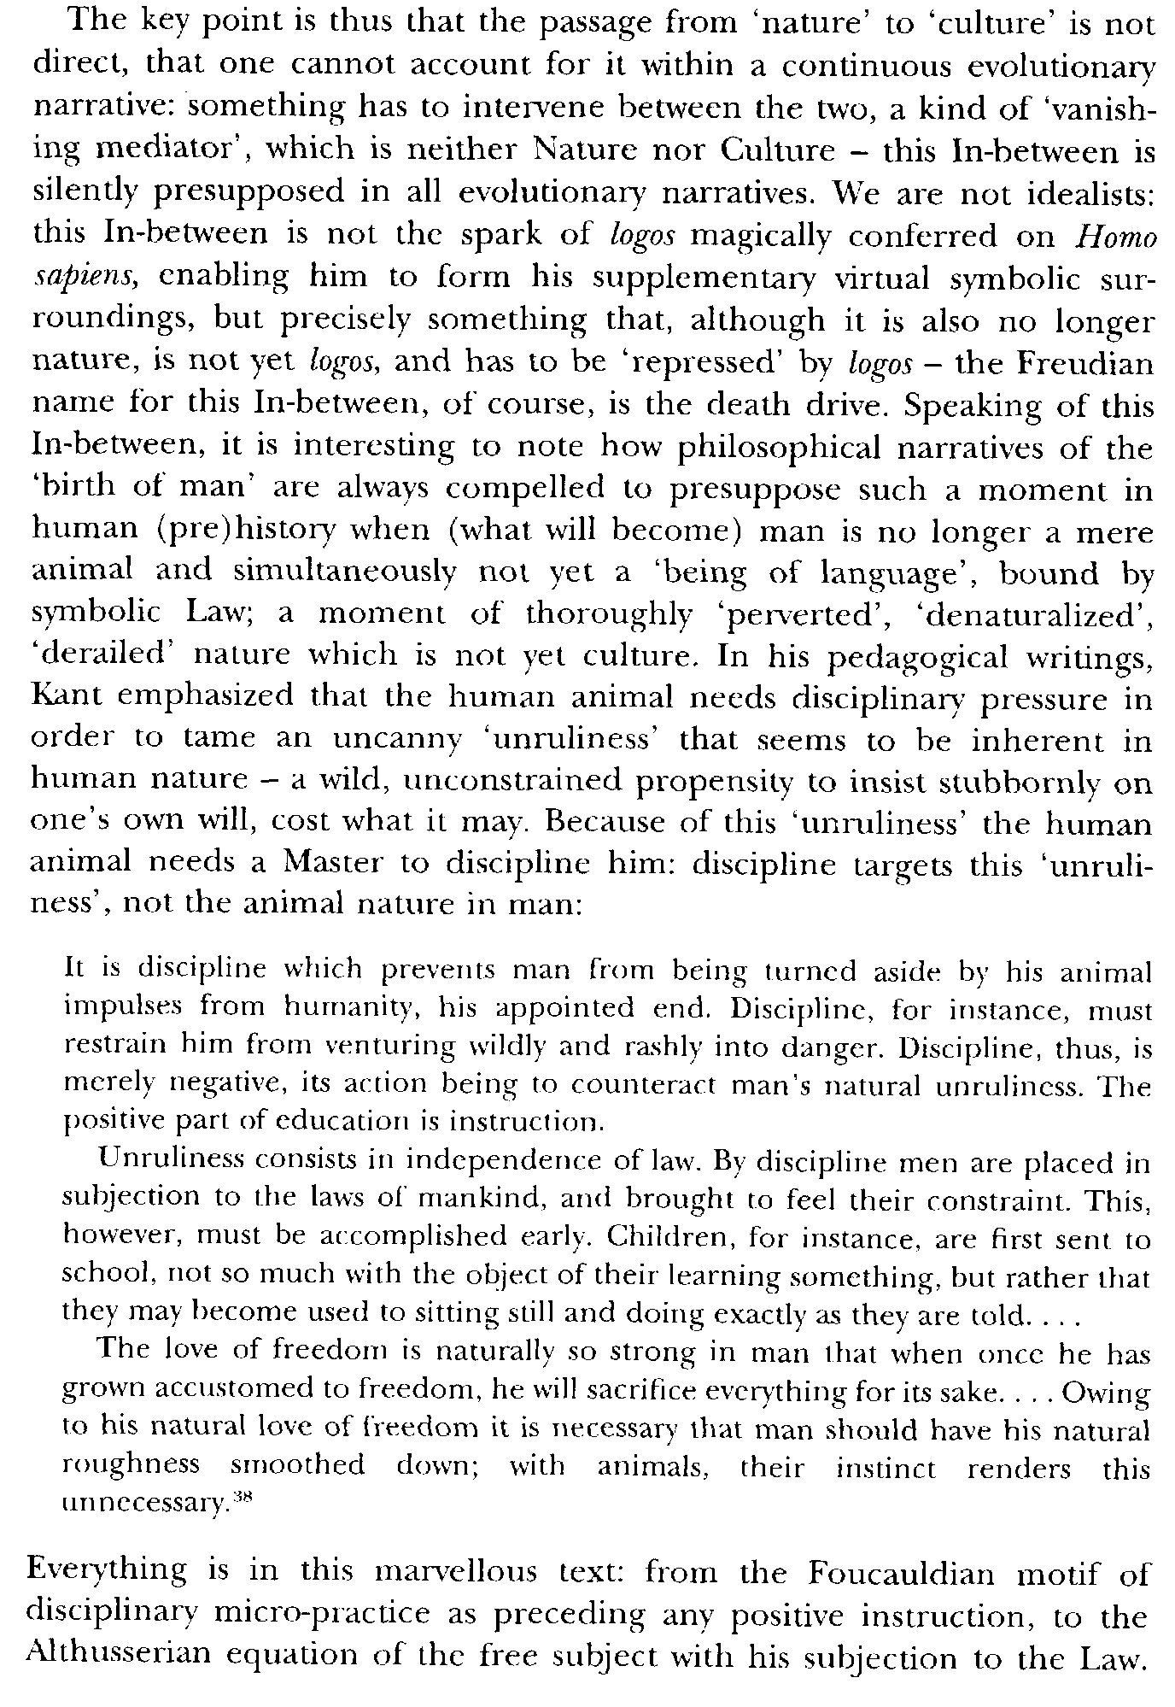
Anthropocentrism cont.
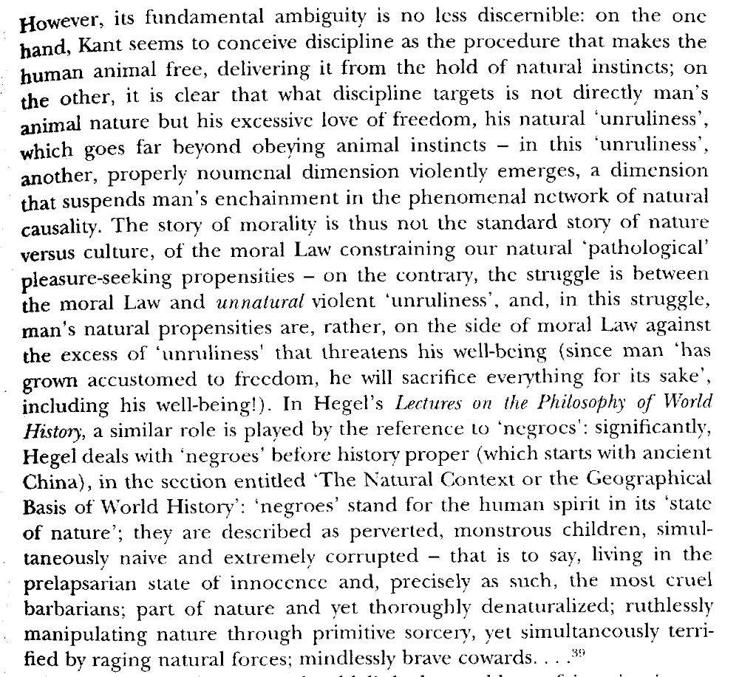

Enviro Managerialism Link/Impact
Hopes for a more perfect social order create a technological mode of thinking which treats the world as an experiment to be managed. However, our futile efforts to solve for harms is always doomed to failure.
Zizek, professor of philosophy and psychoanalysis at the University of Ljubljana, Eastern European OG, general badass, the object of Judith Butler’s hate, 1999 (Slavoj, The Ticklish Subject: The Absent Centre of Political Ontology, Verso, pg 11-12)
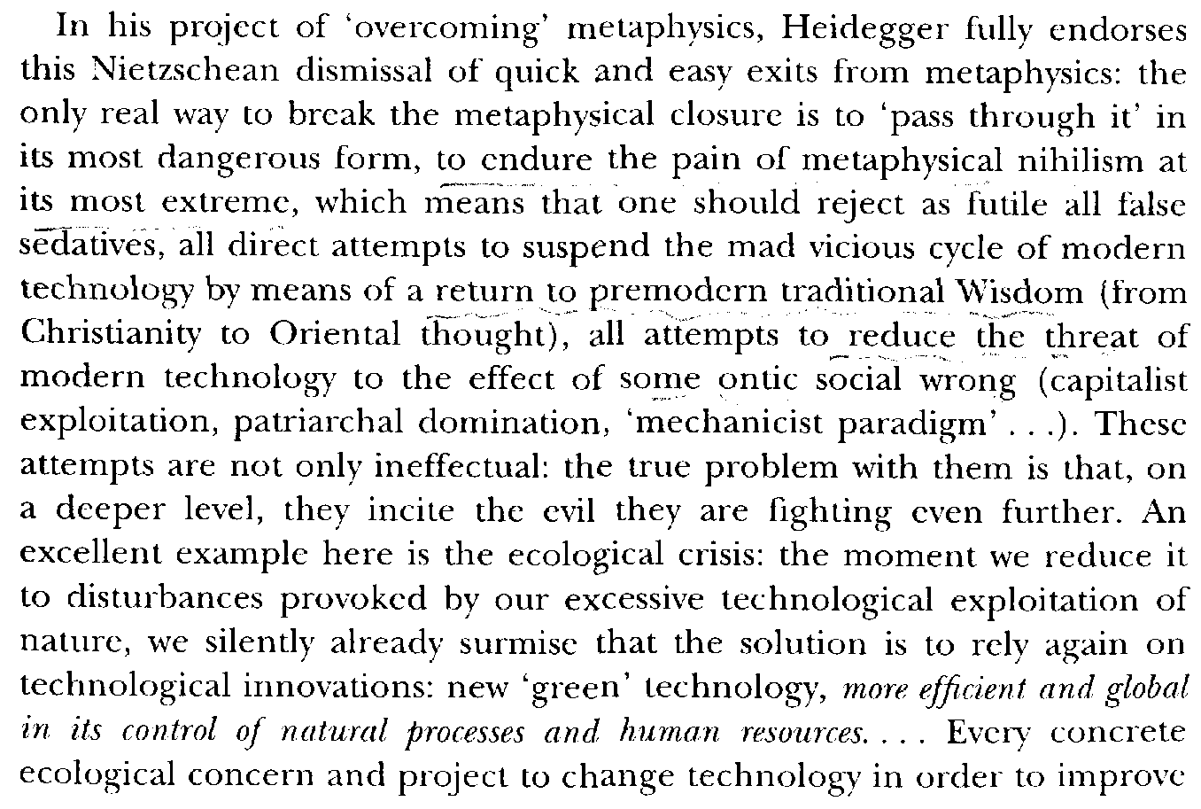

Technological Thought Link
Our technological mode of relating to the environment allows for capitalism to maintain a “human face” that prevents us from realizing the truth of the unbearable reality of capitalism .
Zizek, professor of philosophy and psychoanalysis at the University of Ljubljana, Eastern European OG, general badass, the object of Judith Butler’s hate,1999 (Slavoj, The Ticklish Subject: The Absent Centre of Political Ontology, Verso, pg 12)
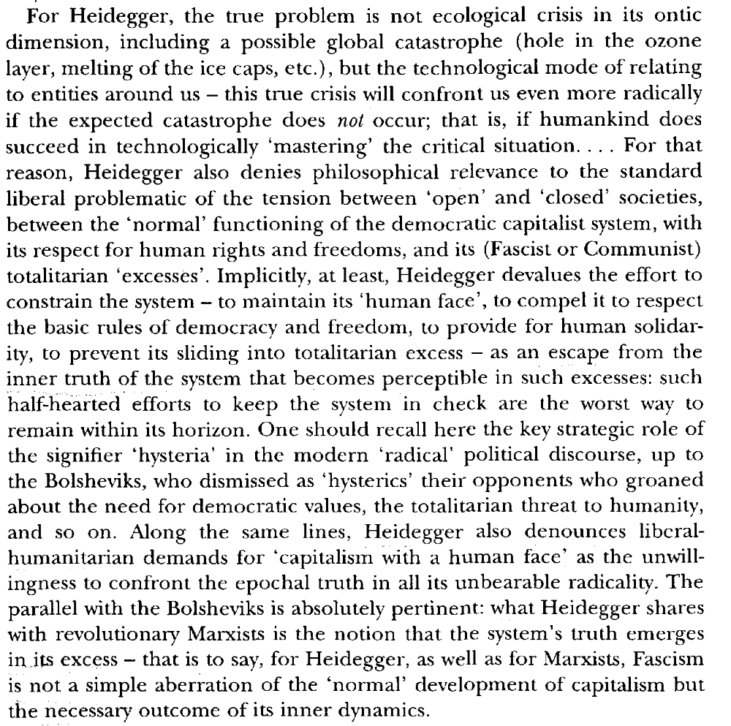

Catastrophe Imagery Link
Capitalism legitimitzes itself through the use of catastrophic images like the 1ac by posing the question, “Think how worse it could be?” which is used to mystify people against the revolution.
Zizek, professor of philosophy and psychoanalysis at the University of Ljubljana, Eastern European OG, general badass, the object of Judith Butler’s hate, 2002 (Slavoj, Revolution at the Gates, Verso, page 167-168)
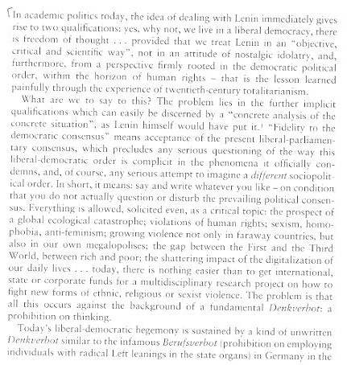
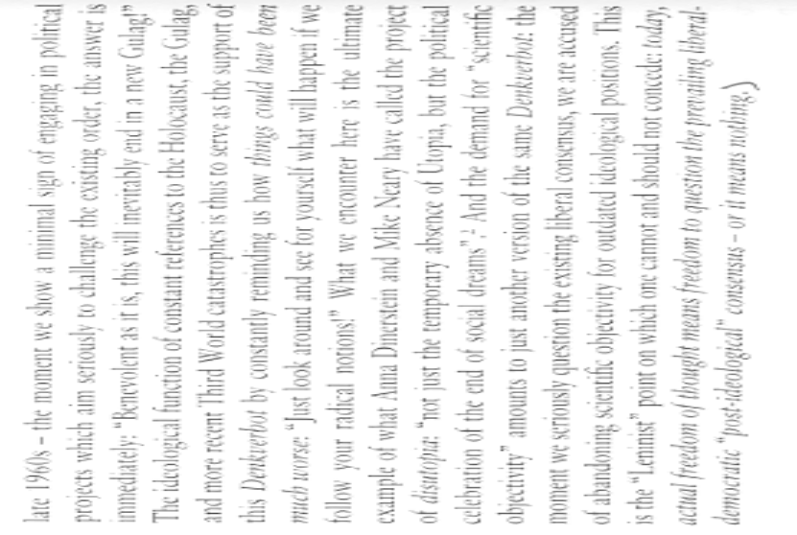
Catastrophe Imagery Link
Capitalism legitimitzes itself through the use of catastrophic images like the 1ac by posing the question, “Think how worse it could be?” which is used to mystify people against the revolution.
Zizek, professor of philosophy and psychoanalysis at the University of Ljubljana, Eastern European OG, general badass, the object of Judith Butler’s hate, 2004 (Slavoj, Revolution at the Gates, Verso, page 167-168)
Exclusion Link
Exclusion of groups is necessary for us to retain our ability to act and to maintain our ontological standing in the world.
Zizek, professor of philosophy and psychoanalysis at the University of Ljubljana, Eastern European OG, general badass, the object of Judith Butler’s hate, 1999 (Slavoj, The Ticklish Subject: The Absent Centre of Political Ontology, Verso, pg 19)
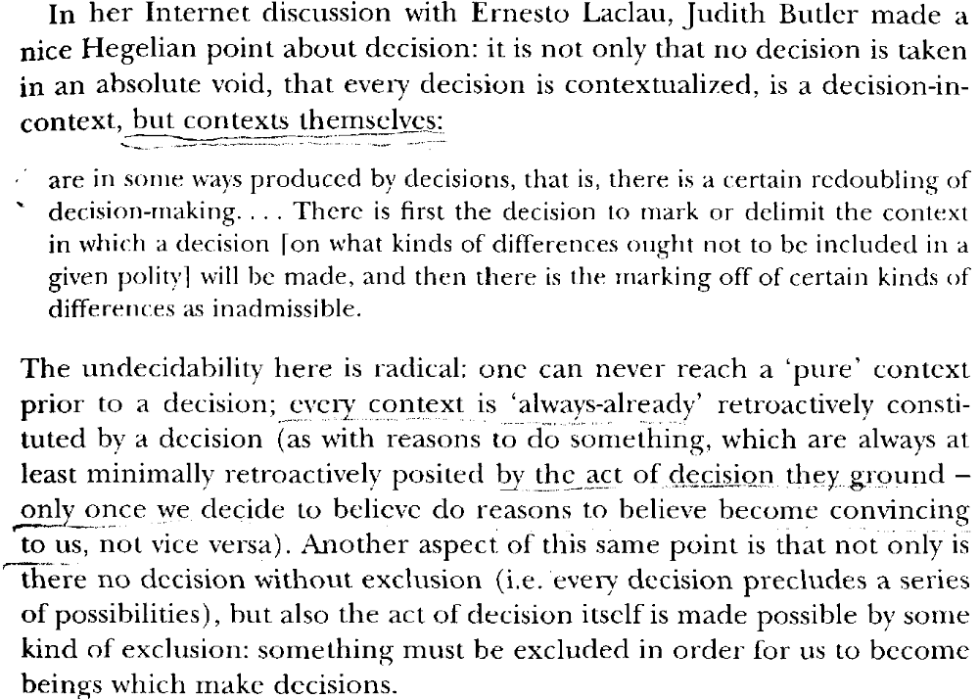
Identity Ptix
Attempts to locate identities is inexorably tied to fantasy- identities aren’t stable and resist identification.
Stavrakakis, Ideology and Discourse Analysis Program in the Department of Government at the University of Essex, 1999 ( Yannis, Lacan and the Political, Ruteledge Press, 31-32)

In other words, any identity resulting from identification is always an unstable identity, a split or even non-identity, since every identification is marked by an alienating dimension. As argued earlier, although imaginary identification offers the subject a sense of identity it also entails a radical ambiguity, it introduces a certain antagonistic tension. The same alienation is characterising symbolic identification: in The Four Fundamental Concepts of Psychoanalysis, Lacan refers to a lack which ‘emerges from the invasion of the symbolic, by the fact that the subject depends on the signifier but the signifier is first of all in the field of the Other’ (XI:204-5). Here we are confronted with an ambivalence similar to the one that led to the failure of imaginary identification. What belongs to the socio-symbolic Other can never become totally ours; it can never become us: it will always be a source of ambivalence and alienation and this gap can never be bridged. The ultimate result of symbolic identification is a further alienation in language, in the social world: ‘The paradox of the Word is therefore that its emergence resolves the tension of the pre-symbolic antagonism, but at a price: the Word…involves an irretrievable externalization-alienation’ (Žižek, 1997a: 42). To recapitulate our argument so far, both imaginary and symbolic identification fail to provide us with a stable identity. A lack is continuously re-emerging where identity should be consolidated. All our attempts to cover over this lack of the subject through identifications that promise to offer us a stable identity fail, this failure brings to the fore the irreducible character of this lack which in turn reinforces our attempts to fill it. This is the circular play between lack and identification which is marking the human condition; a play that makes possible the emergence of a whole politics of the subject. In this regard we have to be very clear, assuming at the same time the risk of a certain repetition: the politics of the subject, the politics of identity formation, can only be understood as a politics of impossibility. If the ego is based on the imaginary misrecognition of the impossibility of fullness and closure, it also entails a constitutive alienation, making visible a certain lack. This lack also constitutes an irreducible element of the symbolic order in which the subject turns for its representation; here lack is elevated to the position of a precondition for symbolic representation. In the symbolic, the subject is properly constituted but as the subject of lack; something is again missing. Identification is thus revealed as, by constitution, alienating (Laclau and Zac, 1994:14). It can never realise its aim, it can never achieve full identity, it can never bring back our lost fullness since it was its own institution that introduced this loss. Identification is always an identification doomed to fail. One has to agree with Laclau and Zac that the proper answer to Lacoue-Labarthe’s rhetorical question ‘Why, after all, should the problem of identification not be, in general, the essential problem of politics?’ is that the problem of politics is identification and its failure (Laclau and Zac, 1994:35). Beyond identity politics, identification politics is revealed as the politics of impossibility.

Multiculturalism Link
Their claims of tolerance for the Other are a sham – they only tolerate the Other insofar as they are deprived of their otherness, turning the case.
Zizek, professor of philosophy and psychoanalysis at the University of Ljubljana, Eastern European OG, general badass, the object of Judith Butler’s hate, 2004 (Slavoj, Revolution at the Gates, Verso, page 174-175)

Law Link
The affirmatives use of the fantasmic Law makes them tied to the ideological control of the status quo.
Dean, Department of Political Science Hobart and William Smith Colleges, 2004 (Jodi, “Zizek on Law”, Springer Netherlands, Law and Critique Volume 15, Number 1 / January, 2004)
For law to function as law, the Real of violence must be concealed. As Zizek explains (with reference to Kant), law's validity requires that we remain within law, that we don't go outside law and emphasize its contingent, historical founding. If we do go outside the law, we can't even see the order as law; its claim to authority becomes just another contingency or act of violence. Zizek is not making a facile point regarding stupid subjects duped by a malevolent legal order. Rather, he is emphasizing the fact that law involves more than the violent, arbitrary, control of people. People need a kind of faith in law; they have to believe it (to believe that others believe it) for it to function at all. The fantasy of an original contract, for example, provides something in which people can believe; this fantasy attaches them to law as it conceals the Real of violence. Belief in law is that something extra that distinguishes law from violence, that separates the founding moment of violence from what comes after it. But how is it that people come to believe in law, especially if they are not simply forced or tricked into belief? How does authority come to be invested in law? As I've mentioned, contract theory offers a particular staging of this moment of investiture. By concealing the violence of law in the story of an original authorization, it offers a justification for the violence of which law avails itself. In Locke’s Second Treatise, for example, persons come together in an original compact to authorize the making of civil laws. They also appeal to the law as that which can protect them, constituting law through this naturalization: it is already there. Both consent and appellation, then, invest law with authority, installing in it that element of faith or attachment that makes it more than violent force. The contingent moment of law’s installation is displaced by the necessary advent of the authority of the eternal or the natural—Reason, Freedom, Justice, etc. Zizek offers alternative explanations for how the Real of violence that haunts the law can be repressed, for how contingent law can be transformed into something perceived as necessary, eternal, authorized, transcendent. His most basic explanation for the investment of meaning in law arises out of his reading of Kafka’s Trial in conjunction with Pascal. In both Kafka and Pascal appears the idea that people cannot accept the fact that law has no authority outside itself, that people have to repress the fact that law is necessary without being true. Zizek argues that the illusion that drives people to believe that truth resides in law can be described by the mechanism of transference: “transference is this supposition of a Truth, of a meaning behind the stupid, traumatic, inconsistent fact of the Law. In other words, ‘transference' names the vicious circle of belief: the reasons why we should believe are persuasive only to those who already believe.” People repress the violent origins of law by positing a Truth behind law to which they transfer their faith or confidence. Law is law because of this Truth; but people only accept the "because" insofar as they already believe in law. For example, one might posit the Divine as the external ground for law, as that source which gives law its validity. Belief in the Divine is transferred to a belief in law. But, if one did not already believe that law was valid, one would not accept this foundation (not to mention the fact that one would have to believe in the Divine as well). Again, the point is that belief is necessary for the reasons for belief to be compelling.

Modern Science Link
Modern Science attempts to close the gap between the Real and the Symbolic in order to harmonize society.
Stavrakakis, Ideology and Discourse Analysis Program in the Department of Government at the University of Essex, 1999 ( Yannis, Lacan and the Political, Ruteledge Press 75-76)
Modernity is primarily associated with the dislocation of traditional constructions of this sort. The unexpected, and doubt, resurface on the horizon and are inscribed, perhaps for the first time with such force, in scientific and philosophical discourse and political imagination. Descartes’ example is revealing since his whole enterprise is based on the recognition of the constitutive nature of doubt. But this position is not eliminating the traumatic character of negativity. It was understandable for people who were used to seek absolute constructions to continue to need them within the modern universe of meaning. This is why modern science ‘reoccupied’ the field of pre-modern certainties. One should not forget that even in Descartes’ argument the constitutivity of doubt is acknowledged only to be eliminated, in a second move, by the emergence of absolute certainty. Thus, the recognition of doubt causes new anti-modern outbreaks that attempt to eliminate doubt anew and create new certainties that would put an end to the continuous questioning entailed by modernity in its critical dimension (Beck, 1997). Although modern science is founded on the critique of pre-modern certainties, of ‘objective’ reason in Horkheimer’s vocabulary, it did not manage to abandon the idea of a harmony between thought and the world, but just replaced the medieval idea that this harmony was preordained with the notion that thought and world could be brought into harmony with the use of a ‘neutral’ and ‘objective’ scientific discourse. (Szerszynski, 1996:107-8) In both cases the aim was to eliminate the distance between the real and reality, to articulate privileged representations of the world with universal validity independent of any social, cultural or discursive context (ibid.). Thus, modernity identified itself with the emergence of absolute certainties in the place of their dislocated pre-modern equivalents. The problem here is that seeking final and objective answers and failing to recognise that every answer of this kind is finite, articulated within a particular historical and social context, signals a return to the pre-modern world (Douglas and Wildavsky, 1982:30). Negating its own founding moment, the moment of doubt and critique, Enlightenment becomes trapped in the pre-modern urge to master the totality of the real, to reach absolute certainty. This is the project of a royal science: The project of a knowledge that would unify this multiplicity of ‘things to be known’ into a homogeneous representable structure, the idea of a possible science of the structure of the real, capable of making it explicit, outside of any false semblance, and of assuring the control over this real without the risks of interpretation (therefore a scientific self-reading of the real, without faults or lack)—this project obviously corresponds to an urgency so vivid, so universally ‘human’, tied (knotted) so well (around the same stake of domination/resistance) to the interests of successive masters of this world, as well as to those of the wretched of the earth, that the phantasm of such an effective, manageable, and transmissible knowledge could not fail historically to use any means to make itself materialize. The promise of a royal science as conceptually rigorous as mathematics, as concretely effective as material technologies, as omnipresent as philosophy and politics—how could humanity resist such a godsend
***Impacts
Ideology is the root cause of Environmental problems
Our refusal to act to prevent global warming is caused by ideology’s attempts to psychologically protect us from our personal involvement in environmental destruction.
Zizek, Professor at the University of Ljubljana and a general badass, 2008 (Slavoj, “Censorship Today: Violence, or........ Ecology as a New Opium for the Masses, )
So, back to the prospect of ecological catastrophe, why do we not act? It is too short to attribute our disbelief in the catastrophe to the impregnation of our mind by scientific ideology, which leads us to dismiss the sane concerns of our common reason, i.e., the gut sense which tells us that something is fundamentally wrong with the scientific-technological attitude. The problem is much deeper, it resides in the unreliability of our common sense itself which, habituated as it is to our ordinary life-world, finds it difficult really to accept that the flow of everyday reality can be perturbed. Our attitude here is that of the fetishist split: "I know very well (that the global warming is a threat to the entire humanity), but nonetheless... (I cannot really believe it). It is enough to look at my environs to which my mind is wired: the green grass and trees, the whistle of the wind, the rising of the sun... can one really imagine that all this will be disturbed? You talk about the ozone hole - but no matter how much I look into the sky, I don't see it - all I see is the same sky, blue or grey!" And therein resides the horror of the Chernobyl accident: when one visits the site, with the exception of the sarcophagus, things look exactly the same as before, life seems to have deserted the site, leaving everything the way it is, and nonetheless we are aware that something is terribly wrong. The change is not at the level of the visible reality itself, it is a more fundamental one, it affects the very texture of reality. No wonder there are some lone farmers around the Chernobyl site who continued to lead their lives as before - they simply ignore all the incomprehensible talk about radiations. Do these farmers not behave like the madman in the old joke circulating among Lacanians to exemplify the key role of the Other's knowledge: a man who believes himself to be a grain of seed is taken to the mental institution where the doctors do their best to finally convince him that he is not a grain but a man; however, when he is cured (convinced that he is not a grain of seed but a man) and allowed to leave the hospital, he immediately comes back very trembling of scare - there is a chicken outside the door and that he is afraid that it would eat him. "Dear fellow," says his doctor, "you know very well that you are not a grain of seed but a man". "Of course I know that," replies the patient, "but does the chicken know it?" The chicken from the joke stands for the big Other which doesn't know. In the last years of Tito's life, he was effectively such a chicken: some archives and memoirs show that, already in the mid-1970s, the leading figures around Tito were aware that Yugoslavia's economic situation was catastrophic; however, since Tito was nearing his death, they made a collective decision to postpone the outbreak of a crisis till his death - the price was the fast accumulation of external debt in the last years of Tito's life. When, in 1980, Tito finally dies, the economic crisis did strike with revenge, leading to a 40 per cent fall of standard of living, to ethnic tensions and, finally, civil and ethnic war that destroyed the country - the moment to confront the crisis adequately was missed. One can thus say that what put the last nail in the coffin of Yugoslavia was the very attempt by its leading circle to protect the ignorance of the Leader, to keep his gaze happy. Is this not what, ultimately, culture is? One of the elementary rules of culture is to know when (and how) to pretend NOT to know (or notice), to go on and act as if something which happened did not happen. When a person near me accidentally produces an unpleasant vulgar noise, the proper thing to do is to ignore it, not to comfort him: "I know it was an accident, don't worry, it doesn't really matter!" We should thus understand in the right way the joke about the chicken: a madman's question is a quite pertinent question in many everyday situations. When parents with a young child have affairs, fight and shout at each other, they as a rule (if they retain a minimum of decency) try to prevent the child to notice it, well aware that the child's knowledge would have had a devastating effect on him - so what they try to maintain is precisely a situation of "We know that we cheat and fight and shout, but the child/chicken doesn't know it." (Of course, in many cases, the child knows it very well, but merely feigns not to notice anything wrong, aware that in this way his parents' life is a little bit easier.) Or, at a less vulgar level, recall a parent in a difficult predicament (dying of cancer, in financial difficulties), but trying to keep this secret from his nearest and dearest...

Turns Case
Our inability to control the natural world and perfect necessarily causes us to lash out using violence.
Zizek, professor of philosophy and psychoanalysis at the European Graduate School in Saas-Fee, 1999 (Slavoj, The Ticklish Subject: The Absent Centre of Political Ontology, Verso, pg 37-38)
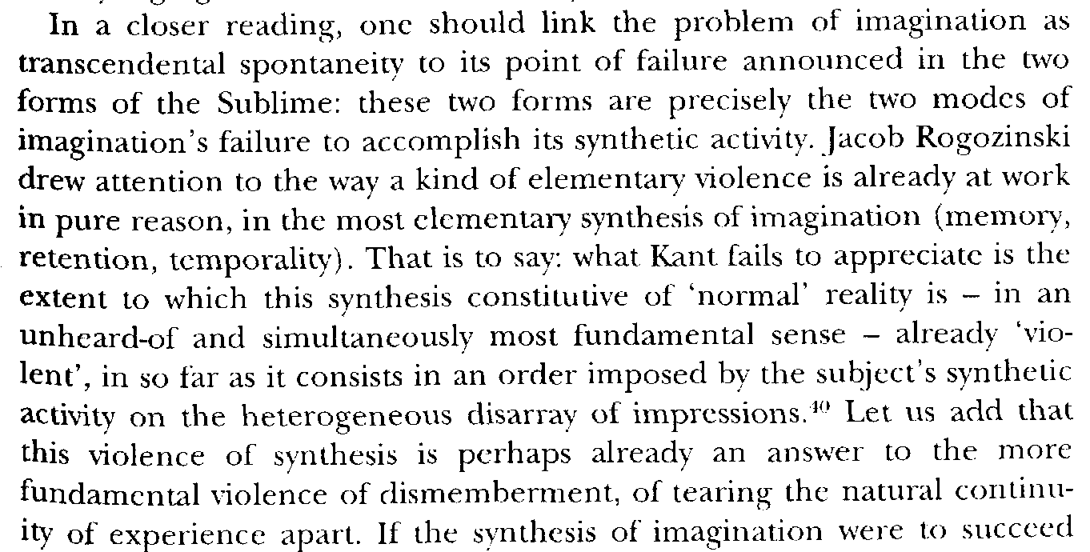

Turns Case cont.
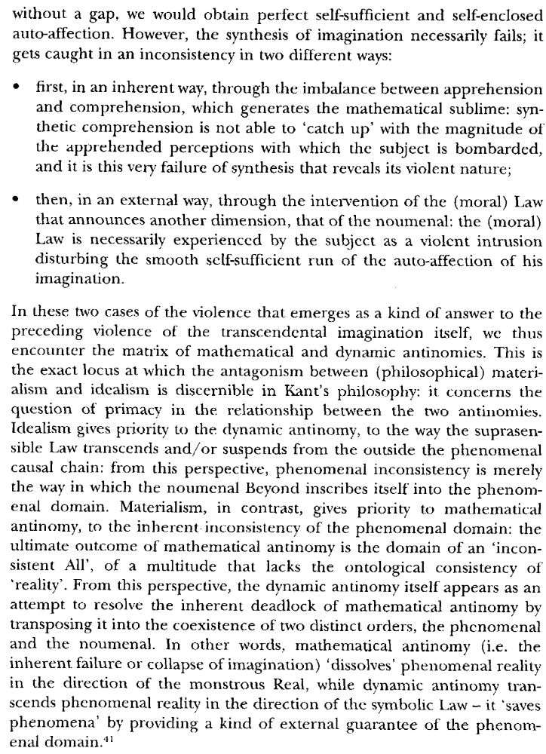
No Solvency
The illusory nature of the fantasy means the promises of the affirmatives case can never be fulfilled.
Stavrakakis, Ideology and Discourse Analysis Program in the Department of Government at the University of Essex, 1999 ( Yannis, Lacan and the Political, Ruteledge Press, 54-55)
Fantasy supports reality This signified function of the nodal point is not, however, solely reduced to its discursive position. It is supported by a whole fantasy construction. As Lacan argues in Identification, the object of fantasy comes to occupy the place of the lacking significance marking the nodal point around which the Other is structured (seminar of 27 June 1962). The construction of reality, the illusion of the world as a wellstructured whole, would not be possible without the intervention of this element of fantasy. In Lacan.s view, .everything we are allowed to approach by way of reality remains rooted in fantasy. (XX:95). As Jacques-Alain Miller has put it with a touch of exaggeration, .reality is fantasy. (Miller, 1995:12). Although in common sense usage and even in some psychoanalytic writing fantasy is opposed to reality, such a view of fantasy cannot be sustained within psychoanalytic theory; this is clear from the beginning in Lacan.s theory of fantasy. As I have already pointed out, reality is not some kind of unproblematic given which can be perceived in one and only one objectively correct way, but something which is discursively constructed (Evans, 1996a:59). The fantasmatic dimension of reality is also revealed in the link Lacan draws between reality and desire. In Lacan, the construction of reality is continuous with the field of desire. Desire and reality are intimately connected, argues Lacan in The Logic of Fantasy (seminar of 16 November 1966). The nature of their link can only be revealed in fantasy.

Scapegoating
Our inability to fill the lack results in the externalization of blame in a process where we exterminate the Other.
Stavrakakis, Ideology and Discourse Analysis Program in the Department of Government at the University of Essex, 1999 ( Yannis, Lacan and the Political, Ruteledge Press, 54-55)
What is this dialectic between the beatific fantasy of nature and the demonised vermin doing if not illustrating the Lacanian dialectic between the two sides of fantasy or between fantasy and symptom? Since we will explore the first of these two Lacanian approaches to fantasy in Chapter 4, we will concentrate here on the fantasy/symptom axis. 20 As far as the promise of filling the lack in the Other is concerned, fantasy can be better understood in its relation to the Lacanian conception of the symptom; according to one possible reading, fantasy and symptom are two inter-implicated terms. It is the symptom that interrupts the consistency of the field of our constructions of reality, of the object of identification, by embodying the repressed jouissance, the destabilising part of nature excluded from its harmonious symbolisation. The symptom here is a real kernel of enjoyment; it is the repressed jouissance that returns and does not ever ‘stop in imposing itself [on us]’ (Soler, 1991:214). If fantasy is ‘the support that gives consistency to what we call reality’ (Žižek, 1989:49) on the other hand reality is always a symptom (Žižek, 1992). Here we are insisting on the late Lacanian conception of the symptom as sinthome. In this conception, a signifier is married to jouissance, a signifier is instituted in the real, outside the signifying chain but at the same time internal to it. This paradoxical role of the symptom can help us understand the paradoxical role of fantasy. Fantasy gives discourse its consistency because it opposes the symptom (Ragland-Sullivan, 1991:16). Hence, if the symptom is an encounter with the real, with a traumatic point that resists symbolisation, and if the discursive has to arrest the real and repress jouissance in order to produce reality, then the negation of the real within fantasy can only be thought in terms of opposing, of stigmatising the symptom. This is then the relation between symptom and fantasy. The self-consistency of a symbolic construction of reality depends on the harmony instituted by fantasy. This fantasmatic harmony can only be sustained by the neutralisation of the symptom and of the real, by a negation of the generalised lack that crosses the field of the social. But how is this done? If social fantasy produces the self-consistency of a certain construction it can do so only by presenting the symptom as ‘an alien, disturbing intrusion, and not as the point of eruption of the otherwise hidden truth of the existing social order’ (Žižek, 1991a:40). The social fantasy of a harmonious social or natural order can only be sustained if all the persisting disorders can be attributed to an alien intruder. To return to our example, the illusory character of our harmonious construction of nature is shown in the fact that there is a part of the real which escapes its schema and assumes a symptomatic form (vermin, etc.); in order for this fantasy to remain coherent, this real symptom has to be stigmatised and eliminated. It cannot be accepted as the excluded truth of nature; such a recognition would lead to a dislocation of the fantasy in question. When, however, the dependence of fantasy on the symptom is revealed, then the play—the relation—between the symptom and fantasy reveals itself as another mode of the play between the real and the symbolic/imaginary nexus producing reality.
Scapegoating/Holocaust
As a result of utopian thinking, groups of people need to be identified as reasons for the failure to fill the lack resulting in extermination.
Stavrakakis, Ideology and Discourse Analysis Program in the Department of Government at the University of Essex, 1999 ( Yannis, Lacan and the Political, Ruteledge Press, 87-88)

In order to realise the problematic character of the utopian operation it is necessary to articulate a genealogy of this way of representing and making sense of the world. The work of Norman Cohn seems especially designed to serve this purpose. What is most important is that in Cohn’s schema we can encounter the three basic characteristics of utopian fantasies that we have already singled out: first, their link to instances of disorder, to the element of negativity. Since human experience is a continuous battle with the unexpected there is always a need to represent and master this unexpected, to transform disorder to order. Second, this representation is usually articulated as a total and universal representation, a promise of absolute mastery of the totality of the real, a vision of the end of history. A future utopian state is envisaged in which disorder will be totally eliminated. Third, this symbolisation produces its own remainder; there is always a certain particularity remaining outside the universal schema. It is to the existence of this evil agent, which can be easily localised, that all persisting disorder is attributed. The elimination of disorder depends then on the elimination of this group. The result is always horrible: persecution, massacres, holocausts. Needless to say, no utopian fantasy is ever realised as a result of all these ‘crimes’—as mentioned in Chapter 2, the purpose of fantasy is not to satisfy an (impossible) desire but to constitute it as such. What is of great interest for our approach is the way in which Cohn himself articulates a genealogy of the pair utopia/demonisation in his books The Pursuit of the Millennium and Europe’s Inner Demons (Cohn, 1993b, 1993c). The same applies to his book Warrant for Genocide (Cohn, 1996) which will also be implicated at a certain stage in our analysis. These books are concerned with the same social phenomenon, the idea of purifying humanity through the extermination of some category of human beings which are conceived as agents of corruption, disorder and evil. The contexts are, of course, different, but the urge remains the same (Cohn, 1993b:xi). All these works then, at least according to my reading, are concerned with the production of an archenemy which goes together with the utopian mentality.

Holocaust (Really good rhetoric)
The result of political utopianism is the creation of a counter hegemonic other who must be exterminated in the name of the elimination of the lack.
Stavrakakis, Ideology and Discourse Analysis Program in the Department of Government at the University of Essex, 1999 ( Yannis, Lacan and the Political, Ruteledge Press,87)
What I will try to do in this chapter is, first of all, to demonstrate the deeply problematic nature of utopian politics. Simply put, my argument will be that every utopian fantasy construction needs a ‘scapegoat’ in order to constitute itself—the Nazi utopian fantasy and the production of the ‘Jew’ is a good example, especially as pointed out in ŽZizek’s analysis. 4 Every utopian fantasy produces its reverse and calls for its elimination. Put another way, the beatific side of fantasy is coupled in utopian constructions with a horrific side, a paranoid need for a stigmatised scapegoat. The naivety—and also the danger—of utopian structures is revealed when the realisation of this fantasy is attempted. It is then that we are brought close to the frightening kernel of the real: stigmatisation is followed by extermination. This is not an accident. It is inscribed in the structure of utopian constructions; it seems to be the way all fantasy constructions work. If in almost all utopian visions, violence and antagonism are eliminated, if utopia is based on the expulsion and repression of violence (this is its beatific side) this is only because it owes its own creation to violence; it is sustained and fed by violence (this is its horrific side). This repressed moment of violence resurfaces, as Marin points out, in the difference inscribed in the name utopia itself (Marin, 1984:110). What we shall argue is that it also resurfaces in the production of the figure of an enemy. To use a phrase enunciated by the utopianist Fourier, what is ‘driven out through the door comes back through the window’ (is not this a ‘precursor’ of Lacan’s dictum that ‘what is foreclosed in the symbolic reappears in the real’?—VII:131). 5 The work of Norman Cohn and other historians permits the articulation of a genealogy of this manichean, equivalential way of understanding the world, from the great witch-hunt up to modern anti-Semitism, and Lacanian theory can provide valuable insights into any attempt to understand the logic behind this utopian operation—here the approach to fantasy developed in Chapter 2 will further demonstrate its potential in analysing our political experience. In fact, from the time of his unpublished seminar on The Formations of the Unconscious, Lacan identified the utopian dream of a perfectly functioning society as a highly problematic area (seminar of 18 June 1958).

Ideology Stifles Environmental Policy
The Big Other psychologically protects us from recognizing our individual role in the degradation of nature resulting in our denial of environmental harms turning the case.
Zizek, Professor at the University of Ljubljana and a general badass, 2008 (Slavoj, “Censorship Today: Violence, or........ Ecology as a New Opium for the Masses, )
The constellation is properly frustrating: although we (individual or collective agents) know that it all depends on us, we cannot ever predict the consequences of our acts - we are not impotent, but, quite on the contrary, omnipotent, without being able to determine the scope of our powers. The gap between causes and effects is irreducible, and there is no "big Other" to guarantee the harmony between the levels, to guarantee that the overall outcome of our interactions will be satisfactory. The problem is that, although our (sometimes even individual) acts can have catastrophic (ecological, etc.) consequences, the big Other prevents us from believing in it, from assuming this knowledge and responsibility: "Contrary to what the promoters of the principle of precaution think, the cause of our non-action is not the scientific uncertainty. We know it, but we cannot make ourselves believe in what we know." This situation confronts us with the deadlock of the contemporary "society of choice" at its most radical. In the standard situation of the forced choice (a situation in which I am free to choose on condition that I make the right choice, so that the only thing left for me to do is the empty gesture of pretending to accomplish freely what is in any case imposed on me). Here, on the contrary, the choice really is free and is, for this very reason, experienced as even more frustrating: we find ourselves constantly in the position of having to decide about matters that will fundamentally affect our lives, but without a proper foundation in knowledge - as John Gray put it: we have been thrown into a time in which everything is provisional. New technologies alter our lives daily. The traditions of the past cannot be retrieved. At the same time we have little idea of what the future will bring. We are forced to live as if we were free.
***Alternative
Traverse the Fantasy of Natural Control
We need to recognize the inevitability of the lack. Only this action can prevent the symbolization of nature which is the root cause of all their impacts.
Stavrakakis, Ideology and Discourse Analysis Program in the Department of Government at the University of Essex, 1999 ( Yannis, Lacan and the Political, Ruteledge Press 74-75)
In the face of the irreducibility of the real we have no other option but to symbolise; but such a symbolisation can take at least two forms: first, a fantasmatic one which will attempt to repress the real and to eliminate once and for all its structural causality. Psychoanalysis favours the second and more complex one: the articulation of symbolic constructs that will include a recognition of the real limits of the symbolic and will attempt to symbolically ‘institutionalise’ real lack. Let me illustrate this point by returning to one of the examples I used earlier, that of nature. The crucial question regarding our access to the natural world becomes now: how can we then, if in fact we can, approach nature before it becomes Nature, the real before it becomes reality, before its symbolisation? This is the question posed by Evernden: how can we return to things ‘before they were captured and explained, in which transaction they ceased to be themselves and became instead functionaries in the world of social discourse [?]’ (Evernden, 1992:110). How can we encounter the pre-symbolic Other in its radical otherness, an otherness escaping all our representations, if he is always ‘beyond’? (ibid.: 118). Well, in fact we can’t; what we can do, however, is acknowledge this failure, this constitutive impossibility, within our symbolisations. Trapped as we are within the world of social meaning, all our representations of reality are doomed to fail due to their symbolic character. Every attempt to construct what is impossible to be constructed fails due to our entrapment within the world of construction. The only moment in which we come face to face with the irreducible real beyond representation is when our constructions are dislocated. It is only when Nature, our construction of external reality, meets a stumbling block, something which cannot be symbolically integrated, that we come close to the real of nature. Nature, constructed Nature, is nothing but ‘a mode of concealment, a cloak of abstractions which obscures that discomforting wildness that defies our paranoid urge to delineate the boundaries of Being’ (Evernden, 1992:132). Only when these boundaries collapse, in that minute intermission before we draw new ones, can we sense the unheimlich of real nature. It is in that sense that—as argued in Chapter 2—Lacanian theory opens the road to a realist constructionism or a constructionist realism; it does so by accepting the priority of a real which is, however, unrepresentable, but, nevertheless, can be encountered in the failure of every construction. One final point before concluding this section: when applied to our own discourse isn’t this recognition introducing a certain ethical principle? Recognising at the same time the impossibility of mastering the real and our obligation to recognise this impossibility through the failure of our attempts to symbolise it, indeed seems to introduce a certain principle which cannot be by-passed. Of necessity this is a principle affecting the structure of knowledge and science in late modern societies. What is, in fact, at stake here is our attitude towards the element of negativity and uncertainty inherent in human experience. The unpredictability and severity of natural forces, for example, have prompted people, from time immemorial, to attempt to understand and master them through processes of imaginary representation and symbolic integration. This usually entails a symbolisation of the real of nature. The product of this symbolisation has frequently been described as a ‘story’ or a ‘paradigm’ about how the world works. We can trace such a story, or many competing stories, in any civilisation or cultural ensemble. Primal people often understood planetary forces and natural disastrous events as acts of god. As Mircea Eliade has pointed out, in The Myth of the Eternal Return, for traditional societies, historic profane events such as natural catastrophes, disasters, and misfortunes, that is to say, every encounter with the real of nature, denote the ‘void’, the non-existent, the unreal par excellence. Thus, they can only produce unbearable terror. They can only be tolerated if conceived as produced by the breaking of a taboo, by a magical action of an enemy or by the divine will; only if integrated, for example, in a schema of indefinite repetition of archetypes revealed ab origine by gods and heroes and repeated by men in cosmogonic recreative rituals and myths. As soon as the cause is pinpointed, the suffering of the encounter with the real of nature becomes tolerable, we have the symbolisation of the real. The suffering now has ‘a [fantasmatic] meaning and a cause, hence it can be fitted into a system and explained’ (Eliade, 1989:98). It is symbolically integrated into a ‘story’ or a ‘paradigm’. What is crucial here is not the exact form of this construction but its ability to provide a meaning capable of alleviating the uncanny character of experience.
Reject the Fantasy
We need to reject the utopian fantasies of the affirmative’s project. Only when recognizing that it is a fantasy can we endlessly traverse and get over it.
Stavrakakis, Ideology and Discourse Analysis Program in the Department of Government at the University of Essex, 1999 ( Yannis, Lacan and the Political, Ruteledge Press 76-78)
In opposition to such a ‘regressive’ attitude, Lacanian theory promotes a return to the founding moment of modernity. Recognising the irreducible character of impossibility, the constitutivity of the real as expressed primarily in the failure of our discursive world and its continuous rearticulation through acts of identification, far from being a postmodern move, reveals the truly modern character of the Lacanian project; instead of a postmodern mysticism it leads to a reorientation of science and knowledge. Recognising the constitutivity of the real does not entail that we stop symbolising; it means that we start trying to incorporate this recognition within the symbolic itself, in fact it means that since the symbolic entails lack as such, we abstain from covering it over with fantasmatic constructs—or, if one accepts that we are always trapped within the field of fantasy, that we never stop traversing it. The guiding principle in this kind of approach is to move beyond fantasy towards a self-critical symbolic gesture recognising the contingent and transient character of every symbolic construct. This is a scientific discourse different from the reified science of standard modernity. I take my lead, in this regard, from Lacan’s text ‘Science and Truth’ (it is the opening lecture of his 1965-6 seminar on The Object of Psychoanalysis). In this particular text, Jacques Lacan stages a critique of modern science as it has been articulated up to now, that is as a discourse constantly identifying the knowledge it produces with the truth of the real. If the constitutive, non-reducible character of the real introduces a lack into human reality, to our scientific constructions of reality for example, science usually attempts to suture and eliminate this gap. Lacan, for his part, stresses the importance of that which puts in danger this self-fulfilling nature of scientific axioms: the importance of the real, of the element which is not developing according to what we think about it. In that sense, science à la Lacan entails the recognition of the structural causality of the real as the element which interrupts the smooth flow of our fantasmatic and symbolic representations of reality. Within such a context, this real, the obstacle encountered by standard science, is not bypassed discretely but introduced within the theory it can destabilise. The point here is that truth as the encounter with the real is ‘encountered’ face to face (Fink, 1995a:140-1). It is in this sense that psychoanalysis can be described as a science of the impossible, a science that does not repress the impossible real. For Lacan, what is involved in the structuration of the discourse of science is a certain Verwerfung of the Thing which is presupposed by the ideal of absolute knowledge, an ideal which ‘as everybody knows…was historically proved in the end to be a failure’ (VII: 131). In other words, we cannot be certain that definite knowledge is attainable. In fact, for Lacan, certainty is not something we should attribute to our knowledge of things. Certainty is a defining characteristic of psychosis. In Lacan’s view, it constitutes its elementary phenomenon, the basis of delusional belief (III:75). Opening up our symbolic resources to uncertainty is, on the other hand, the only prudent move we have left. What we can know has to be expressed within the structure of language but this structure has to incorporate a recognition of its own limits. This is not a development which should cause unease; as Nancy has put it What will become of our world is something we cannot know, and we can no longer believe in being able to predict or command it. But we can act in such a way that this world is a world able to open itself up to its own uncertainty as such…. Invention is always without a model and without warranty. But indeed that implies facing up to turmoil, anxiety, even disarray. Where certainties come apart, there too gathers the strength that no certainty can match.

***Answers To Section
A2 Perm
This break from ideology will not be easy. Liberation hurts and the move away from capitalism will be with substantial violence but this violence is necessary to achieve the break from the Symbolic.
Zizek, general badass and Professor at the University of Ljubljana, 2003 ( Slavoj, “Liberation Hurts” http://www.lacan.com/zizekillinois.htm)
A kind of litmus test is - this always works on all my friends - "How do you stand toward Fight Club, the movie?" All the liberals claim, "Ah, it's proto-fascist, violent, blah, blah, blah." No, I am for it. I think the message of Fight Club is not so much liberating violence but that liberation hurts. What may falsely appear as my celebration of violence, I think, is a much more tragic awareness. If there is a great lesson of the 20th-century history, it's the lesson of psychoanalysis: The lesson of totalitarian subordination is not "renounce, suffer," but this subordination offers you a kind of perverted excess of enjoyment and pleasure. To get rid of that enjoyment is painful. Liberation hurts. In the first act of liberation, as I develop it already in The Fragile Absolute, where I provide lots of violent examples - from Keyser Söze in The Usual Suspects, who kills his family (which I'll admit, got me into lots of trouble) to a more correct example, Toni Morrison's Beloved. But, of course, now, I'm not saying what Elizabeth Wright, who edited a reader about me, thought. I love her, an English old lady. I had tea with her once, and she said, "I liked your book, The Fragile Absolute, but something bothered me. Do I really have to kill my son to be ethical?" I love this total naïveté. Of course not! My point was to address the problem of totalitarian control. The problem is: how does a totalitarian power keep you in check? Precisely by offering you some perverse enjoyment, and you have to renounce that, and it hurts. So, I don't mean physical violence, or a kind of fetishization of violence. I just mean simply that liberation hurts. What I don't buy from liberals is this idea of, as Robespierre would have put it, "revolution without revolution," the idea that somehow, everything will change, but nobody will be really hurt. No, sorry, it hurts.
A2 Perm

The permutation re-entrenches ideology – their recognition of the Big Other before the act allows their revolution to be co-opted.
Zizek, professor of philosophy and psychoanalysis at the University of Ljubljana, Eastern European OG, general badass, the object of Judith Butler’s hate, 2002 (Slavoj, Revolution at the Gates, Verso, page 8)
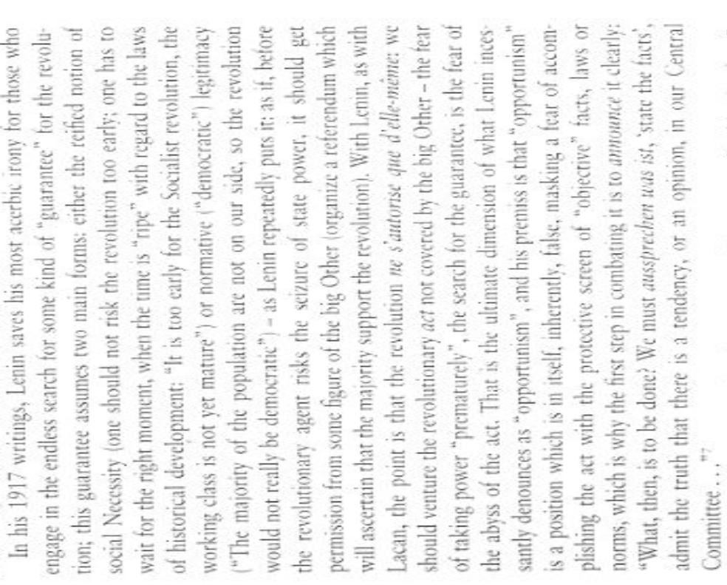

A2 Alt doesn’t solve/ It’s impossible/ Cap inevitable
Focus on the impossibility of our actions are misled. Ideology attempts to make us believe we can never attain the Real.
Johnston, Dept of Philisophy at Univ. of New Mexico, 2004 (Adrian, “The Cynic’s Fetish: Slavoj Žižek and the Dynamics of Belief, Pshycoanalysis, Culture, and Society, December)
Žižek explains his changes of mind as regards ideology and the category of impossibility thus: I am no longer satisfied with my own old definition of ideology here the point was that ideology is the illusion which fills in the gap of impossibility and inherent impossibility is transposed into an external obstacle, and that therefore what needs to be done is to reassert the original impossibility. This is the ultimate result of a certain
transcendentalist logic: you have an a priori void, an original impossibility, and the
cheating of ideology is to translate his inherent impossibility into an external obstacle; the illusion is that by overcoming this obstacle you get the Real Thing. I am almost tempted to say that the ultimate ideological operation is the opposite one: that is, the very elevation of something into impossibility as a means of postponing or avoiding encountering it. He continues: Again, I am almost tempted to turn the standard formula around. es, on the one hand, ideology involves translating impossibility into a particular historical blockage, thereby sustaining the dream of ultimate fulfillment—a consummate encounter with the Thing. On the other hand… ideology also functions as a way of regulating certain distance with such an encounter. It sustains at the level of fantasy precisely what it seeks to avoid at the level of actuality: it endeavours to convince us that the Thing cannot ever be encountered, that the Real forever eludes our grasp. So ideology appears to involve both sustenance and avoidance in regard to encountering the Thing. He immediately adds that “an elevation into impossibility” is “the fundamental operation” underpinning “the ideological dimension. Accordingly, Žižek repeatedly defines authentic political practice as involving “the art of the impossible” insofar as a genuine politics worthy of the name succeeds at changing the very conceptions of what is and isn’t possible in a given situation—a political intervention accomplishes what before seemed unthinkably impossible. Žižek faults his early work for having fallen into the trap of treating the Real as a kind of Kantian noumenality, namely, as an inaccessible dimension that invisibly-yet-inexorably disrupts the other registers of human reality (i.e., the Imaginary and the Symbolic). Speaking of The Sublime Object of Ideology (his first book in English), he claims that its “philosophical weakness” is that, “it basically endorses a quasi-transcendental reading of Lacan, focused on the notion of the Real as the impossible Thing-in-itself; in so doing, it opens the way to the celebration of failure: to the idea that every act ultimately misfires, and that the proper ethical stance is heroically to accept this failure.” The word “act” is crucial here, since it designates that which Žižek relies upon so as to avoid the resigned pessimism coloring much of Freudian-Lacanian psychoanalysis. Thanks to the notion of the act sketched by Lacan, one doesn’t have to accept the Real as a negative limit cordoning off an impossible Beyond that simply must be observed and respected as such; one doesn’t have to concede that the subject is always and ultimately a dysfunctional slave to the past, the id, the symbolic order, the drives, the libidinal economy, and so on, given that radical breaks with all these overdetermining factors are possible (despite, from a more traditional psychoanalytic view, the seeming impossibility of such total departures into the New). Through a perhaps excessive emphasis on an underdeveloped Lacanian concept, Žižek allows himself to sustain a sort of cynical distance from the present state of the capitalist situation. According to Žižek, an act is an intervention that “makes the impossible happen” by virtue of rewriting the very rules concerning what is and isn’t possible in a given reality.
A2 Alt Doesn’t Solve
And the alternative solves. Ideology only exists because we give it symbolic authority.
Johnston, Dept of Philisophy at Univ. of New Mexico, 2004 (Adrian, “The Cynic’s Fetish: Slavoj Žižek and the Dynamics of Belief, Pshycoanalysis, Culture, and Society, December)
Žižek makes the paradoxical move of arguing, alongside his rejection of a stable distinction between subjectivity and sociality, that the big Other of the symbolic order only effectively exists (albeit in an illusory, ephemeral fashion) insofar as subjects treat it “as if” it possessed a stable, independent reality as an overarching system of collective mediation—“there is an ‘objective’ socio-symbolic system only insofar as subjects treat it as such.” Žižek continues, insisting that, “Lacan is… no Durkheimian: he opposes any reification of the Institution, i.e., he knows very well that the Institution is here only as the performative effect of the subject’s activity. The Institution exists only when subjects believe in it, or, rather, act (in their social interactivity) AS IF they believe in it.” The big Other is, in a manner of speaking, nothing more than a self-fulfilling prophecy. An appropriate analogy/metaphor here is a group of people, none of who want anything to do with the others, being brought together for a social function such as a party. None of the participants in the party has any desire to be there. In short, the urge or inclination to sustain the social group is nowhere to be found amongst any of the constituent elements of the group. And yet, the gathering happens (the party actually takes place and lasts for the specified period of time in spite of everyone’s contrary desires). The sole requisite condition for this is that each person believes that the other people there have a desire to engage in this social function. The very glue that holds the entire event together is the fact that each person in attendance attributes to or projects onto his/her respective others the desire to be there (a desire ostensibly absent in each and every person making this attribution or doing this projecting). A belief in the “desire of the Other” (in this case, the subjectively hypothesized/hypostatized “general will” of the collective of others) prompts subjects caught up in this dynamic to apply to themselves the felt pressure of obligation necessary for their de facto acquiescence to the given social arrangement. A virtual, nonexistent desire, a spectral desire with enough power concretely to shape social reality, arises, in a bottom-up, emergent fashion, out of a network of attributions and projections. This desire doesn’t exist within any of the particular nodes of the network, and yet nonetheless circulates throughout the network as its unifying force. The odd implication here is that, on this Lacanian-Žižekian account, banal human reality is an ex nihilo effect produced through the mutual interpellation of two voids wherein each (erroneously) posits the existence of the other. On one side, the “barred S” of subjectivity is conjured into being through a resistance generated by and against insertion into the symbolic order’s chains of signifiers (i.e., the subject, although perpetually escaping confinement within determinate representations, is parasitically dependent upon the representational networks of the big Other); on another side, the big Other, supposedly responsible for giving birth to subjectivity, is itself an inexistent fiction or “transcendental illusion,” a function reliant upon the manners in which subjects actively-yet-unwittingly alienate themselves by reifying it (Lacan signals this dimension of the grand Autre by “barring” it in addition to the subject). Reality is hence sustained in the space of overlap between the barred subject and the barred Other. One is reminded of Lacan’s claim that an ideal image of the relation between subject and Other is two interlocking tori, a unity held together as a consistent whole insofar as each torus passes through the empty space at the center of its complementary partner (the core of each of these entities being utterly vacant).
A2 Link Turn
Cynicism and active resistance only allow the Big Other to maintain its stranglehold on the population
Johnston, Dept of Philosophy at Univ. of New Mexico, 2004 (Adrian, “The Cynic’s Fetish: Slavoj Žižek and the Dynamics of Belief, Psychoanalysis, Culture, and Society, December)
Throughout the course of his entire intellectual itinerary, Žižek repeatedly underscores
the importance of “cynical distance,” an attitude of bemused or mocking disbelief, for the
effective functioning of ideologies (with Peter Sloterdijk’s work on cynicism being one of the influences behind this Žižekian motif). Subjects acquiesce to a system of rules, norms, and conventions (i.e., a big Other) only so long as they are somehow able to sustain a minimal sense of sane selfhood or individuality vis-à-vis conceiving of themselves as skeptics reluctantly going along with the run of things amidst a herd of simplistic, gullible believers, namely, amidst others who believe in their place as “subjects supposed to believe”—“individuals transpose their belief on to the big Other (embodied in the collective), which therefore believes in their place—individuals remain sane qua individuals, maintaining the distance towards the ‘big Other’ of the official discourse.”In explaining “how ideology seems to work today,” Žižek observes that, “we perform our symbolic mandates without assuming them and ‘taking them seriously.’”In Žižek’s depictions, the subject playing this cynical game of unconsciously pulling the wool over his/her eyes—this cynicism makes de facto deferential obedience to socio-symbolic authority psychically tolerable—adopts a perspective identical to that of the fetishist as described by Octave Mannoni (an analyst-student of Lacan): “I know full well, but nonetheless…” Today’s bourgeois commodity fetishists, imagining themselves to be enlightened-yet-jaded realistic pragmatists entering a hard-headed “post-ideological” age, forcefully ignore the fact that their position is itself wholly and completely suffused with ideology. Modern cynics are the most fervent of faithful believers, clinging to their favored fictions through a cunning series of projections and externalizations (one should note that, for Žižek, belief isn’t an inherent, first-person psychological property or state of mind, but a floating, transitive function capable of multiple forms of displacement). The gap between what late-capitalist cynics say and what they actually do in terms of socially performed behavior indicates that, “the modern subject explicitly claims not to believe, while in his unconscious (fantasy) he does so.” Behind the stylized, fashionable stance of très chic post-modern disbelief in “The System” (or, in popular slang, “The Man”) lurks modernity’s authoritarian dictum as formulated by Kant in his 1784 essay “What Is Enlightenment?”: “Argue as much as you want and about what you want, but obey!”The current strategy of capitalist liberal-democratic ideology encourages individuals to be as dismissive as they desire precisely so that they find their conformity bearable as something depersonalized, disavowed, and thereby held at arm’s length. Nobody ever presents themselves as a conformist; everyone today is an anti-conformist, somehow identifiable as a special individual despite external appearances to the contrary. With all this anti-conformity in the air, it’s truly amazing that the social machinery of production manages to function even to the slightest degree
A2 Revolution→ Totalitarianism
Breaking down ideological domination is key to ending repressive regimes
Zizek, professor of philosophy and psychoanalysis at the University of Ljubljana, Eastern European OG, general badass, the object of Judith Butler’s hate, 2002 (Slavoj, Revolution at the Gates, Verso, page 195 -196)

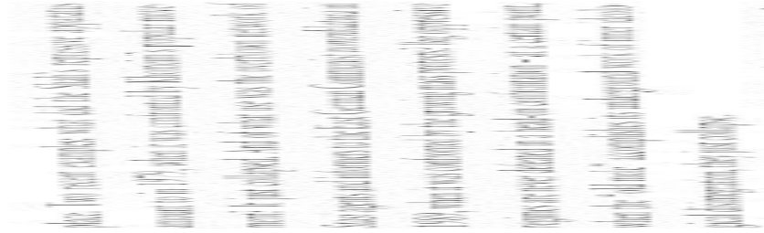
A2 Case outweighs
Take the risk that our Act isn’t absolute. Taking the plunge of failure ensures our success.
Johnston, Dept of Philisophy at Univ. of New Mexico, 2004 (Adrian, “The Cynic’s Fetish: Slavoj Žižek and the Dynamics of Belief, Pshycoanalysis, Culture, and Society, December)

Although an act is indeed not an action (and although far from every action can or does become an act), there is, nonetheless, no act without an action. A politics of the pure act, one that eschews engaging in any specifications concerning actions to be performed, is an empty “politics without politics.” The risk that this position refuses isn’t the risk of the “absolute Act” and its always-possible failure—it risks refusing the active specification and performance of actions that might not end up becoming acts. The activity of thinking that Žižek hopes to facilitate again by toppling certain implicit ideological prohibitions must not allow itself to neglect grappling with the tangible details of, for instance, social and political policymaking. Is the passivity of awaiting the messianic future arrival of the undefined act-miracle the sole viable replacement for Marx’s abandoned political project of communism?

A2 Case Outweighs
Their refusal to risk it all means their act will fail.
Johnston, Dept of Philisophy at Univ. of New Mexico, 2004 (Adrian, “The Cynic’s Fetish: Slavoj Žižek and the Dynamics of Belief, Pshycoanalysis, Culture, and Society, December)

Žižek argues that a genuine materialist embraces the taking of risks with no guarantee whatsoever of a subsequent good result—“True materialism… consists precisely in accepting the chanciness without the implication of the horizon of hidden meaning—the name of this chance is contingency.” And, reiterating a thesis argued for by Badiou in his 1985 text Peut-on penser la politique?, he claims that the liberal-democratic belief system of free-market capitalism uses the bogeyman of “totalitarianism”—people often insist that the danger of recreating nightmarish Stalinist or fascist dictatorships justifies the avoidance of any radical measures deviating from accepted mainstream political wisdom in the West— to de-legitimize just this sort of “materialism.” In other words, the specter of totalitarianism is invoked so as to silence demands for taking chances by intellectually entertaining possibilities pronounced impermissible by capitalist democracy—“the notion of ‘totalitarianism,’ far from being an effective theoretical concept, is a kind of stopgap: instead of enabling us to think… it relieves us of the duty to think, or even actively prevents us from thinking.” Žižek continues, noting that, “Today, reference to the ‘totalitarian’ threat sustains a kind of unwritten Denkverbot (prohibition against thinking).” Hence, the phrase “repeating Lenin” doesn’t refer to the ridiculously anachronistic and ineffective posturing that would be involved in another attempt at launching a communist revolution. For Žižek, it broadly signifies a disruptive break that makes it possible to imagine, once again, viable alternatives to liberal-democratic capitalism by removing the various obstacles to thinking seriously about options forcefully foreclosed by today’s reigning ideologies—“‘Lenin’ stands for the compelling FREEDOM to suspend the stale existing [post]ideological coordinates, the debilitating Denkverbot in which we live—it simply means that we are allowed to think again.” Žižek links liberal democracy’s employment of the threat of totalitarianism to a more fundamental rejection of the act itself qua intervention whose consequences cannot safely be anticipated. In Žižek’s view, contemporary democracy legitimates itself through a pathetic posture in which the avoidance of risk (i.e., of extreme measures not covered by preexisting democratic consensuses, measures with no guarantee of status-quo-affirming success) is elevated to the status of the highest political good—“what the reference to democracy involves is the rejection of radical attempts to ‘step outside,’ to risk a radical break.” The refusal to risk a gesture of disruption because it might not turn out exactly the way one envisions it should is the surest bulwark against change:
Framework
We can’t sit around and wait forever- we need to take action against capitalism regardless of the circumstances. (probably some sort of f/w card)
Zizek, professor of philosophy and psychoanalysis at the University of Ljublijana, Eastern European OG, general badass, the object of Judith Butler’s hate, 2004 (Slavoj, Revolution at the Gates, Verso, page 8-9)
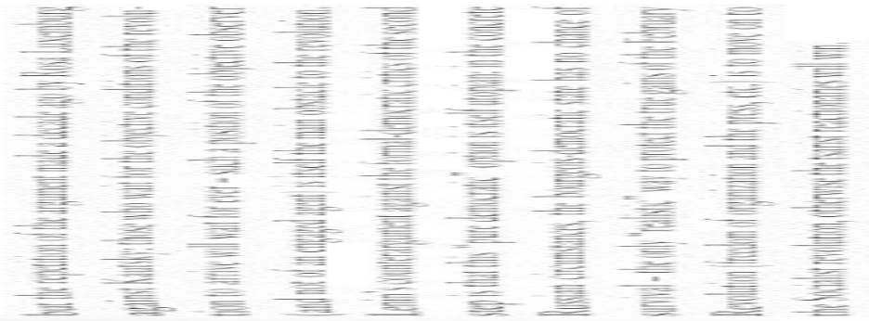
A2 Zizek is Tautological
Zizek rejects tautologies about the law for being violent.
Meyers, former lecturer at the University of Stirling, 2008 (Tony, “Slavoj Zizek-Key Ideas”, http://www.lacan.com/zizekchro1.htm)
Zizek refers to the law throughout his work. The term "the law" signifies the principles upon which society is based, designating a mode of collective conduct based upon a set of prohibitions. However, for Zizek, the rule of the law conceals an inherent unruliness which is precisely the violence by which it established itself as law in the first place. "At the beginning" of the law, there is a certain "outlaw", a certain real of violence which coincides with the act itself of the establishment of the reign of the law... The illegitimate violence by which law sustains itself must be concealed at any price, because this concealment is the positive condition of the functioning of the law. (For They Know Not What They Do: Enjoyment as a Political Factor) The authority of the law stems not from some concept of justice, but because it is the law. Which is to say that the origin of the law can be found in the tautology: "the law is the law". If the law is to function properly, however, we must experience it as just. It is only when the law breaks down, when it becomes a law unto itself, and it reaches the limits of itself, do we glimpse those limits and acknowledge its contingency by reference to the phrase "the law is the law".
A2 Robinson
Robinson groups 6 contradictory “Lacanian Authors” and doesn’t take into account the differences between them.
Thomassen, Department of Government, University of Essex, 2004 (Lasse, “Lacanian Political Theory: A Reply to Robinson”, BJPIR: 2004 VOL 6, 558–561)
(1) Robinson tells us that, although there are differences among the books under review, ‘[t]here are, however, sufficient similarities between the books under review here to suggest that they belong to a single approach, sufficiently similar to each other and sufficiently different from other varieties of post-structuralism to qualify as a distinct paradigm’ (p. 259). The ‘approach’ or ‘paradigm’ is referred to as ‘an ontology of lack’, (p. 269), ‘[a]n approach to politics drawn from Lacanian psychoanalysis’ (p. 259), ‘Lacanian politics’ (p. 260) and ‘Lacanianism’ (p. 267), and the theorists are referred to as ‘Lacanians’ (p. 260) and ‘Lacanian theorists’ (p. 268). Although the use of labels like these can be useful, one must be careful. First of all, although I would contend that Mouffe could be classified as a theorist of lack, she is hardly a Lacanian. In the book reviewed by Robinson, she makes only a general reference to Lacan (Mouffe 2000, 34). In addition, she makes reference to the developments of an ethics of psychoanalysis inspired by the work of Lacan in the works of Slavoj Zizek, Yannis Stavrakakis and John Rajchman (Mouffe 2000, 137–139). These developments, she argues, dovetail with her own approach, but neither she nor anyone else has ever claimed that she is ‘a Lacanian’ (Robinson 2004, 263). It thus seems to be possible to be a ‘theorist of lack’ without being a ‘Lacanian’, and one should not confuse the two. Indeed, it seems that we are dealing here with an instance of what Robinson is criticising, namely the subsumption of a concrete instance (Mouffe) to an a priori category (‘Lacanian’) with no regard to the specificity of the former. Moreover, there are important differences between the theorists reviewed by Robinson. Stavrakakis, for instance, has criticised the work of Badiou and i ek (Stavrakakis 2003), and Zizek has criticised Laclau for not being radical enough (Butler, Laclau and Zizek 2000). More examples could be given, but the important point here is that when one talks about ‘approaches’ and ‘paradigms’, one must be careful to specify exactly what it is that unites the theorists within the approach or paradigm. Robinson also recognises this: ‘The differences between the texts under review mainly arise around the issue of how to articulate Lacanian themes into a concrete political discourse’ (p. 261). That is, we can talk about a Lacanian approach or an approach inspired by an ontology of lack even though there are differences in the extent to which the theorists interpret Lacanian themes or the ontology of lack respectively. The identification of an approach can, for instance, serve as the focal point for a discussion of the relative merits of different poststructuralist approaches (see Tønder and Thomassen (forthcoming)). Indeed, Robinson seems to aim at precisely this; that is, Robinson’s aim is to rescue poststructuralist political theory from Lacanian political theory (pp. 259, 268ff.). However, his critique of Lacanian political theory (as I shall call it) seems to rest on a conception of political theory hardly reconcilable with what can broadly be referred to as post-structuralism. What is at stake here is what kind of political theory is possible from a post-structuralist perspective.
A2 Robinson
Zizekian politics does not preclude progressive change.
Thomassen, Department of Government, University of Essex, 2004 (Lasse, “Lacanian Political Theory: A Reply to Robinson”, BJPIR: 2004 VOL 6, 558–561)
According to Robinson, Lacanian political theory is inherently conservative. ‘Lacanians’, Robinson writes, ‘urge that one reconcile oneself to the inevitability of lack. Lacanian politics is therefore about coming to terms with violence, exclusion and antagonism, not about resolving or removing these’ (p. 260). And, about Mouffe, he writes that, ‘as a Lacanian, Mouffe cannot reject exclusion; it is, on a certain level, necessary according to such a theory’ (p. 263). Such assertions are only possible if we believe in the possibility of opposing exclusion to a situation of non-exclusion, which is exactly what post-structuralists have challenged. Moreover, the post-structuralist (and Lacanian) view does not necessarily preclude the removal of any concrete exclusion. On the contrary, the acknowledgement of the constitutivity of exclusion shifts the focus from exclusion versus non-exclusion to the question of which exclusions we can and want to live with. Nothing in the poststructuralist (and Lacanian) view thus precludes a progressive politics. Of course, this is not to say that a progressive politics is guaranteed—if one wants guarantees, post-structuralist political theory is not the place to look. There are similar problems with Robinson’s characterisation of Zizek’s ‘nihilistic variety of Lacanianism’: ‘the basic structure of existence is unchangeable ... [ Zizek’s] Lacanian revolutionism must stop short of the claim that a better world can be constructed’ (p. 267). This, according to Robinson, ‘reflects an underlying conservatism apparent in even the most radical-seeming versions of Lacanianism’ (p. 268). Again, the constitutivity of exclusion and violence does not necessarily mean that ‘the new world cannot be better than the old’ (p. 268). The alternative to guaranteed progress is not necessarily conservatism or nihilism, and the impossibility of a perfect society does not exclude attempts at improvement—with the proviso that what counts as improvement cannot be established according to some transcendental yardstick.

A2 Robinson
Lacanian abstract ontology is key to formulating a specific political action.
Thomassen, Department of Government, University of Essex, 2004 (Lasse, “Lacanian Political Theory: A Reply to Robinson”, BJPIR: 2004 VOL 6, 558–561)
Robinson believes that, since Lacan did not provide a specific theory of politics, but only a more abstract ontology, all the political appropriations of Lacan can do is to subsume politics to pregiven Lacanian categories (p. 261). This is obviously a potential danger, and one that must be avoided. One must insist that analytical categories are always rearticulated when applied; as Wittgenstein has shown, there is no application that leaves intact the rule being applied. But this does not preclude the theorisation of politics through categories that were not originally thought to apply (directly or indirectly) to politics. This would assume a regional conception of politics: politics as determined as a particular region with particular (essential) limits and requiring a theory only applicable to this region. This, in turn, would require a theory transcending all regions and thus capable of delimiting the specifically political region—again not a feasible alternative from a post-structuralist viewpoint. It is the merit of, among others, the theorists considered by Robinson, that they have introduced a distinction between, on the one hand, politics as the region of practices usually referred to as politics and, on the other hand, the political as the moment of the contingent institution of politics and the social. The political cannot be reduced to a specific region, but instead refers to a logic permeating society in its entirety, even if in some places more than others. Since the political understood as contingency permeates politics, we can use the political as a principle of analysing politics. This is one of the contributions of post-structuralist (including Lacanian) political theory.
***Affirmative Answers
Perm
Refusal to act in ethical situations and instead to defer to other actors allows for complacency in genocide.
(Zizek, professor of philosophy and psychoanalysis at the University of Ljubljana, Eastern European OG, general badass, the object of Judith Butler’s hate, 2002 (Slavoj, Revolution at the Gates, Verso, page 194)
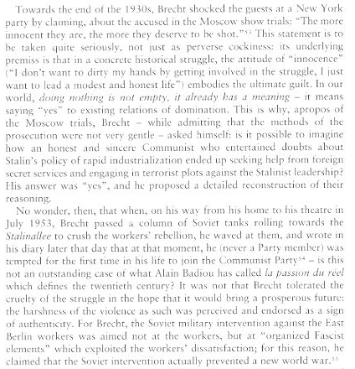
Perm
We can try to avert threats and criticize the notion of fantasies.
Crosswhite, professor of English, University of Oregon,2001 (Jim, A Response to Slavoj Zizek’s “Welcome to the Desert of the Real” September 25 http://www.uoregon.edu/~jcross/response_to_zizek.htm)
And it is difficult to understand what he is asking at the end: "Or will America finally risk stepping through the fantasmatic screen separating it from the Outside World, accepting its arrival into the Real world, making the long-overdue move from 'A thing like this should not happen HERE!' to 'A thing like this should not happen ANYWHERE!'." Of course, to abandon the "here" for the "anywhere" would be foolish. We are in real bodies in real places with real limitations and with real work to do. It is not simply a "fantasmatic screen" that deeply attaches people in a unique way to the sufferings of their neighbors and their fellow citizens. But the demand that Zizek makes is neither unfamiliar nor inappropriate. It is more than worth pursuing. What can we do to work to see that what the people of New York City suffered on September 11 does not happen anywhere,;neither in the U.S. nor anywhere else? The reactions of the American government now threaten regions all over the world and seriously threaten liberty and privacy and tolerance in the United States. The American past carries humanitarian successes and catastrophic failures and genocide. Perhaps fantastic critique has a role to play. Certainly we must struggle to sustain serious social criticism through threatening times, but unless we are simply displaying critical virtuosity, we must achieve a kind of criticism that is reasonably concrete, less pretending to ultimate truths of history, more capable of acknowledging the real suffering of real people, criticism that is not too proud to descend to the practicable. What do we seek now? First, to avert a catastrophe. We must undo the terrorist networks and prevent American anger and power from leading us into the catastrophic roles that seem to have been scripted for us. Five thousand innocents are murdered in New York City. That is more than enough. Every dead innocent fuels more anger, either from the powerless or from the powerful. Averting an escalation of global violence is the immediate and pressing task. Undoing and weakening the terrorist networks, withdrawing support from them, arresting the guilty—everyone who is not already a monster must be persuaded to join in this. Restraining American power and calming American anger—all Americans must work tirelessly on this in their own ways. Steadily and powerfully and consistently exposing and addressing and undoing the intolerance that threatens—all Americans must engage in this struggle.
Perm
We can combine collective action with the traversal of the fantasy in order to prevent authoritarian regimes.
Robinson and Tormey, School of Politics, University of Nottingham, 2005 (Andrew and Simon, “A TICKLISH SUBJECT? ZIZEKAND THE FUTURE OF LEFT RADICALISM” Thesis Eleven, Vol. 80, No. 1, 94-107)
Moreover, we would take issue with Zizek’s model of the pledged group bound together by the One who Acts as a step backwards from the decentred character of current left-radical politics. Nor need this decentring be seen as a weakness, as Zizek insists it should. It can be seen as a strength, protecting radical politics from self-appointed elites, transformism, infiltration, defeat through the ‘neutralization’ of leaders, and betrayal. In contrast with Zizek’s stress on subordination, exclusivity, hierarchy and violence, the current emphasis on the adoption of anti-authoritarian, heterogeneous, inclusive and multiform types of activity offer a better chance of effectively overcoming the homogenizing logic of capitalism and of winning support among wider circles of those dissatisfied with it. Similarly, the stress on the centrality of direct action – which includes ludic, carnivalesque and a variety of non-violent actions – generates the possibility of empowerment through involvement in and support for the myriad causes which make up the anticapitalist resistance. This resistance stands in stark contrast to the desert of ‘heroic’ isolation advocated by Zizek which, as Laclau puts it, is ‘a prescription for political quietism and sterility’ (Butler et al., 2000: 293). Zizek is right that we should aim to overcome the ‘impossibilities’ of capitalism, but this overcoming should involve the active prefiguration and construction in actuality of alternative social forms, not a simple (and actually impossible) break – with everything which exists – of the kind imagined by Zizek. It is important that radicals invoke ‘utopias’, but in an active way, in the forms of organization, ‘disorganization’, and activity adopted – in the spaces created for resistance and in the prefiguration of alternative economic, political and social forms. Utopian imaginaries express what is at stake in left radicalism: that what exists does not exist of necessity, and that the contingency of social institutions and practices makes possible the transcendence of existing institutions and the construction or creation of different practices, social relations and conceptions of the world. The most Zizek allows radicals is the ability to ‘glimpse’ utopia while enacting the reconstruction of oppression. Radicals should go further and bring this imagined ‘other place’ into actual existence. Through enacting utopia, we have the ability to bring the ‘no-where’ into the ‘now-here’.

Perm-Small Demands
We need to throw small demands against the state that we know won’t be fulfilled in order to break out of our ideological slumber.
Zizek, Professor of Psychoanalysis and Philosophy at the University of Ljubljana, Eastern European OG, general badass, 2007 ( Slavoj, “Resistance is Surrender”, London Book Review, November 15, http://www.lrb.co.uk/v29/n22/zize01_.html)
It is striking that the course on which Hugo Chávez has embarked since 2006 is the exact opposite of the one chosen by the postmodern Left: far from resisting state power, he grabbed it (first by an attempted coup, then democratically), ruthlessly using the Venezuelan state apparatuses to promote his goals. Furthermore, he is militarising the barrios, and organising the training of armed units there. And, the ultimate scare: now that he is feeling the economic effects of capital’s ‘resistance’ to his rule (temporary shortages of some goods in the state-subsidised supermarkets), he has announced plans to consolidate the 24 parties that support him into a single party. Even some of his allies are sceptical about this move: will it come at the expense of the popular movements that have given the Venezuelan revolution its élan? However, this choice, though risky, should be fully endorsed: the task is to make the new party function not as a typical state socialist (or Peronist) party, but as a vehicle for the mobilisation of new forms of politics (like the grass roots slum committees). What should we say to someone like Chávez? ‘No, do not grab state power, just withdraw, leave the state and the current situation in place’? Chávez is often dismissed as a clown – but wouldn’t such a withdrawal just reduce him to a version of Subcomandante Marcos, whom many Mexican leftists now refer to as ‘Subcomediante Marcos’? Today, it is the great capitalists – Bill Gates, corporate polluters, fox hunters – who ‘resist’ the state. The lesson here is that the truly subversive thing is not to insist on ‘infinite’ demands we know those in power cannot fulfil. Since they know that we know it, such an ‘infinitely demanding’ attitude presents no problem for those in power: ‘So wonderful that, with your critical demands, you remind us what kind of world we would all like to live in. Unfortunately, we live in the real world, where we have to make do with what is possible.’ The thing to do is, on the contrary, to bombard those in power with strategically well-selected, precise, finite demands, which can’t be met with the same excuse.
Ideological Control Inevitable
The plan does nothing to reinforce ideological control – rather, we will inevitably break free of ideology through our endless demands on the state.
Zizek, Professor of Psychoanalysis and Philosophy at the University of Ljubljana, Eastern European OG, general badass, 2007 ( Slavoj, “Resistance is Surrender”, London Book Review, November 15, http://www.lrb.co.uk/v29/n22/zize01_.html)
One of the clearest lessons of the last few decades is that capitalism is indestructible. Marx compared it to a vampire, and one of the salient points of comparison now appears to be that vampires always rise up again after being stabbed to death. Even Mao’s attempt, in the Cultural Revolution, to wipe out the traces of capitalism, ended up in its triumphant return. Today’s Left reacts in a wide variety of ways to the hegemony of global capitalism and its political supplement, liberal democracy. It might, for example, accept the hegemony, but continue to fight for reform within its rules (this is Third Way social democracy). Or, it accepts that the hegemony is here to stay, but should nonetheless be resisted from its ‘interstices’. Or, it accepts the futility of all struggle, since the hegemony is so all-encompassing that nothing can really be done except wait for an outburst of ‘divine violence’ – a revolutionary version of Heidegger’s ‘only God can save us.’ Or, it recognises the temporary futility of the struggle. In today’s triumph of global capitalism, the argument goes, true resistance is not possible, so all we can do till the revolutionary spirit of the global working class is renewed is defend what remains of the welfare state, confronting those in power with demands we know they cannot fulfil, and otherwise withdraw into cultural studies, where one can quietly pursue the work of criticism. Or, it emphasises the fact that the problem is a more fundamental one, that global capitalism is ultimately an effect of the underlying principles of technology or ‘instrumental reason’. Or, it posits that one can undermine global capitalism and state power, not by directly attacking them, but by refocusing the field of struggle on everyday practices, where one can ‘build a new world’; in this way, the foundations of the power of capital and the state will be gradually undermined, and, at some point, the state will collapse (the exemplar of this approach is the Zapatista movement). Or, it takes the ‘postmodern’ route, shifting the accent from anti-capitalist struggle to the multiple forms of politico-ideological struggle for hegemony, emphasising the importance of discursive re-articulation. Or, it wagers that one can repeat at the postmodern level the classical Marxist gesture of enacting the ‘determinate negation’ of capitalism: with today’s rise of ‘cognitive work’, the contradiction between social productio€n and capitalist relations has become starker than ever, rendering possible for the first time ‘absolute democracy’ (this would be Hardt and Negri’s position). These positions are not presented as a way of avoiding some ‘true’ radical Left politics – what they are trying to get around is, indeed, the lack of such a position. This defeat of the Left is not the whole story of the last thirty years, however. There is another, no less surprising, lesson to be learned from the Chinese Communists’ presiding over arguably the most explosive development of capitalism in history, and from the growth of West European Third Way social democracy. It is, in short: we can do it better. In the UK, the Thatcher revolution was, at the time, chaotic and impulsive, marked by unpredictable contingencies. It was Tony Blair who was able to institutionalise it, or, in Hegel’s terms, to raise (what first appeared as) a contingency, a historical accident, into a necessity. Thatcher wasn’t a Thatcherite, she was merely herself; it was Blair (more than Major) who truly gave form to Thatcherism.

Resistance → Violence
Resistance to ideology only gives justifies the Big Other’s response of violence
Zizek, Professor of Psychoanalysis and Philosophy at the University of Ljubljana, Eastern European OG, general badass, 2007 ( Slavoj, “Resistance is Surrender”, London Book Review, November 15, http://www.lrb.co.uk/v29/n22/zize01_.html)
The response of some critics on the postmodern Left to this predicament is to call for a new politics of resistance. Those who still insist on fighting state power, let alone seizing it, are accused of remaining stuck within the ‘old paradigm’: the task today, their critics say, is to resist state power by withdrawing from its terrain and creating new spaces outside its control. This is, of course, the obverse of accepting the triumph of capitalism. The politics of resistance is nothing but the moralising supplement to a Third Way Left. Simon Critchley’s recent book, Infinitely Demanding, is an almost perfect embodiment of this position.[*] For Critchley, the liberal-democratic state is here to stay. Attempts to abolish the state failed miserably; consequently, the new politics has to be located at a distance from it: anti-war movements, ecological organisations, groups protesting against racist or sexist abuses, and other forms of local self-organisation. It must be a politics of resistance to the state, of bombarding the state with impossible demands, of denouncing the limitations of state mechanisms. The main argument for conducting the politics of resistance at a distance from the state hinges on the ethical dimension of the ‘infinitely demanding’ call for justice: no state can heed this call, since its ultimate goal is the ‘real-political’ one of ensuring its own reproduction (its economic growth, public safety, etc). ‘Of course,’ Critchley writes, history is habitually written by the people with the guns and sticks and one cannot expect to defeat them with mocking satire and feather dusters. Yet, as the history of ultra-leftist active nihilism eloquently shows, one is lost the moment one picks up the guns and sticks. Anarchic political resistance should not seek to mimic and mirror the archic violent sovereignty it opposes.
Law Negates the Law
Our introduction legislation is a liberating process that negates the previous laws and the ideologies accustomed with them
Dean, Department of Political Science Hobart and William Smith Colleges, 2004 (Jodi, “Zizek on Law”, Springer Netherlands, Law and Critique Volume 15, Number 1 / January, 2004)
Law begins in trauma. From the standpoint of the old law, the violent establishing of something new is crime. The old law is disobeyed, overthrown, transgressed, usurped. From the standpoint of the new law, this crime is self-negating. It vanishes (or is concealed) as a crime once the new order is constituted. Put somewhat differently, the establishment of law overthrows law, for example, the law of custom, the law of nature, or even law as an ideal that only existed at the very moment of its loss. And, because establishing is overthrowing, there is a risk--the negation of law such. Establishing manifests a disregard for law as it perversely (or criminally) turns crime into law. This paradox, this traumatic identity of law and crime, is the repressed origin of law. The transition from the Articles of Confederation to the Constitution of the United States well illustrates such a traumatic identity of law and crime. Delegates from the thirteen states had been commissioned to revise the Articles. But, when they met in Philadelphia in 1787, they ran away with the convention. Instead of simply altering the Articles, they rewrote them from the bottom up, shifting sovereignty from the states to the people. From the standpoint of their critics, this was a usurpation, an unauthorized transmutation of the government. At least one delegate to the convention worried that it would lead to a civil war.

Alt doesn’t Solve
Traversing the fantasy fails to rid the world of the dominant ideological control- it merely replicates it into a worse form.
Nicol, University College at Chichester, 1999 (Brian ,“As If: Traversing the Fantasy in Zizek,” PARAGRAPH, V24 I2 )
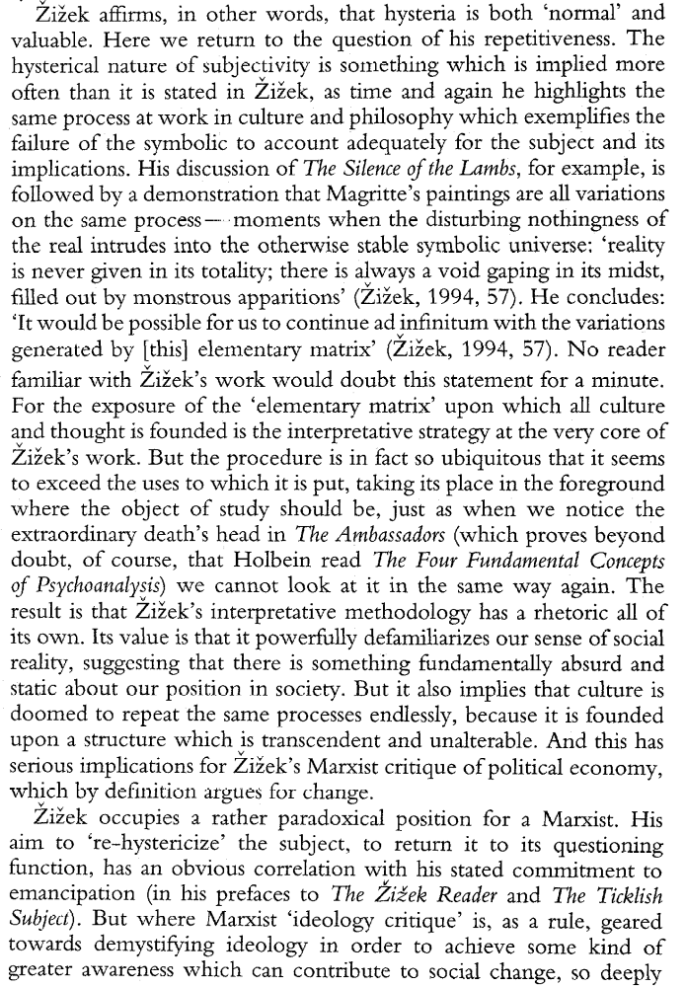

Alt doesn’t Solve cont.
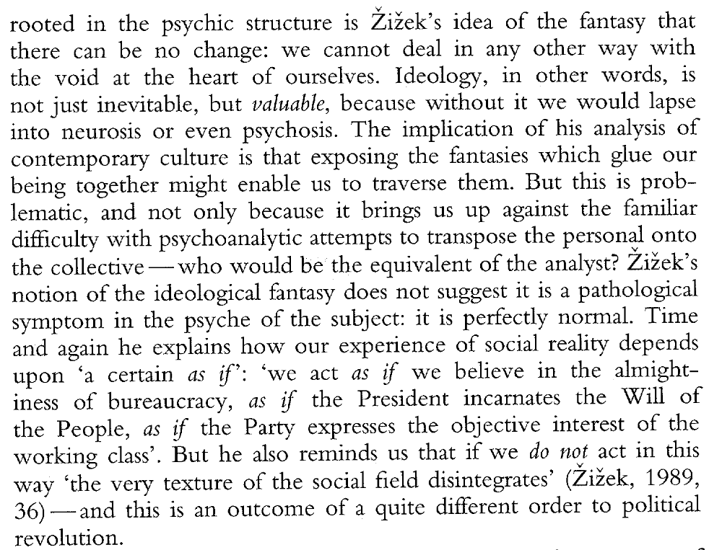

Alt Doesn’t Solve
The repetition of the forced choice doesn’t break the subject free of the Symbolic Order.
Butler, Senior Lecturer in English, Media and Art History at the University of Queensland, 2004 (Rex, “Slavoj Zizek: A Live Theory, http://www.lacan.com/zizek-butler.htm)
But, to get back to our main point, the paradox here is that it is in remarking upon transference that our speakers produce transference. It is in speaking of the way that their message is always distorted that their message is never distorted. The intersubjective element of philosophy, the fact that its authority comes from us, is not simply irreconcilable with the authority of philosophy but is its real basis. And this is the ambiguity of object a as at once what is in the subject 'more than themselves' and the stand-in for that 'act' that would repeat and thus reveal the 'forced choice'. For let us go back to that 'act' by means of which we are able to relive this forced choice as though it has not yet happened, and which opens us up to something 'before' or 'outside' of the symbolic order. The example Zizek gives of it in "Why is Every Act?" is Antigone's famous 'No!' to King Creon's refusal to allow her brother Polynices a proper burial. It is a gesture that places her outside of the social, that proposes a radically different set of values, and which therefore can only be judged in its own terms. As Zizek writes: This 'law' in the name of which Antigone insists on Polynices' right to burial is the law of the 'pure' signifier prior to every positive law that judges our deeds: it is the law of the Name which fixes our identity beyond the eternal flow of generation and corruption. (E!, 92) And yet, ironically, to all intents and purposes, this 'No!' is exactly like the word of the master-signifier itself, which can also only be judged tautologically and requilts the social field, forcing us to read everything in a new way. And this, again, is the difficulty we have with our master-thinkers and why it is so hard to think 'after' them, for in a sense the concepts they propose are nothing positive but only the 'inscription of a pure difference' (E!, 91), already naming their own difference from themselves. That is, as we have seen with the concepts of class and the unconscious, we could no sooner name their absence, our difference from them or even the fact that they arise only in their relationship to us, than these would return to them as what they are already about. It is they that would remark before us their own absence and difference from themselves.12 As Zizek admits, this standing outside of the forced choice can only end up repeating it. This act comes down finally to a choice not whether to enter the symbolic or not but between two alternatives already within the symbolic. As Zizek makes clear in that other diagram he reproduces in the chapter (E!, 76), object a still lies within the set defined by S1 and S2, two different master-signifiers. Or, as he puts it there: 'The subject cannot "have it all" and choose himself as nonbarred; all he can choose is a partial mark, one of two signifiers, the symbolic mandate that will represent him, designate his place in the intersubjective network' (E!, 76). Or, as he will elsewhere say, paraphrasing Lacan, the choice comes down to that between 'bad' and 'worse' (E!, 75), which perhaps is not simply that between a master-signifier within the symbolic order and a psychotic act outside of it, but is always echoed - insofar as we are a 'split' subject - in the choice between two signifiers within the symbolic order. But it is in this context that we must read Zizek carefully - and perhaps even against himself - when he states that in Lacan's 'suspension' of the master-signifier we might somehow see '[the master's-place] visible in its original emptiness, i.e., as preceding the original element which fills it out'. For, as Zizek himself argues, this object a only 'comes into being through being lost, i.e., it is not given prior to its loss' (E!, 75). In other words, this empty place is never given as such but is only ever a retrospective effect of it being filled in. The repetition of the forced choice never really comes up with a different decision, never actually chooses otherwise; but this repetition itself testifies to something always not chosen. Again, as Zizek says with regard to the notion of the working through of 'trauma' in psychoanalysis, it is not so much some prior existing alternative that is either recollected or not as a fleeting possibility that arises in the present, at the very moment it is not chosen. As in Kierkegaard's notion of the religious, we do not so much repeat some particular thing or even decision as the very failure to make a decision: 'Insofar as repetition is not possible, it is possible to repeat the very experience of impossibility' (E!, 79). And in repeating it as impossible, we do not merely render it possible, change the course of events, but think what is excluded to ensure that things are as they are, what is allowed by this always unchosen alternative. This is the very 'transcendental' philosophical gesture as such, understanding how what is stands in for a certain fundamental impossibility. It is for this reason too that this act of which we are speaking is not some 'exception reconciled in the universal' (E!, 84), or at least not in any obvious sense. For this repetition of the forced choice is not in the end a breaking or transgression of the symbolic order. It is not directly opposed to or outside of it. As we have already seen, we can only overturn one prescription by another prescription, one transference by

Alt Doesn’t Solve Cont.
another transference. Rather, what this 'possibility' opened up by the act suggests is that, even though there is no actual outside to the symbolic order, even though any attempt to think something prior to it
can only choose an alternative already within it, all this is only possible because of a certain 'outside', a certain 'alternative' forever excluded. It is precisely what Zizek means by the Real as a kind of 'transhistorical kernel' (E!, 81), for which object a stands in. Again, it would not be so much anything prior to the symbolic as what is excluded at the very moment it is included, what each of these master-signifiers tries to speak of, what each of these 'doublings' or 'requiltings' seeks to respond to. And what this forces us to think is both that there is nothing outside of the symbolic order (this object a will always turn into another master-signifier) and this symbolic is empty, contains nothing (in a way does not exist until the 'free' decision to enter it). At the very moment the symbolic order 'doubles', names its own difference from itself, there is also something that 'doubles' it, which cannot be named. As opposed to any 'exception reconciled in the universal', there is at once no exception and all is exception. And this is the ambiguity of object a as that 'law of the name', let us say of the master-signifier: it is both only a new master-signifier, which cannot be lost, and what allows this loss to be recorded, that without which this loss would not exist. It is this equivalence that Zizek speaks of throughout his work in terms of the Hegelian formulae 'the Spirit is a Bone' (E!, 88) and the monarch as the identity of the 'State qua rational totality and the "irrational", biological positivity of the king's body' (E!, 86). It is also the particular rhythm that characterizes Zizek's work: a kind of 'Schellingian' simultaneous contraction and expansion, in which proper names and concepts at once channel the disseminatory drift of the writing and argument and open it up to the loss of coherence and sense.

Zizek Indict
Zizek’s arguments rely on the premise of what he already said is true – meaning his arguments are tautological.
Harpham, president and director of the National Humanities Center in North Carolina, 2003 (Galt, “Doing the Impossible: Slavoj Zizek and the End of Knowledge, Critical Inquiry Volume 29, Number 3, Spring)
The standard format of argumentation is so deeply ingrained in academic culture that it generally goes unremarked. An argument begins with a hypothesis, a testable characterization of the data in a limited field. It proceeds by such means as adducing evidence, drawing inferences, proposing counterarguments, probing provisional conclusions in a spirit of skeptical inquiry, and eliminating contradictions, all of which lead towards a conclusion, a summative statement whose various elements have passed through the fires of rigorous and disinterested testing. This process functions as the form of fairness, an agreement to display the means by which a conclusion is achieved in order to prevent the mere reiteration of prejudice or the interference of desire. While this process cannot, of course, altogether eliminate flaws of observation, description, or reasoning, it does at least invite the scholarly conversation to continue, because conclusions arrived at in this way can either be challenged on the grounds of procedural flaws or can serve as the starting point for further investigation. Zizek's work, by contrast, seems to be formed almost entirely of endgames in which the sense of conclusion, with its payoffs and rewards, is always present. A sharply diminished experience of orderly progress is compensated for by the continual feeling of arrival and by the constant surprises afforded by an exceptionally rich and quirky use of examples, which I discuss in more detail below. The effect is that of a stream of nonconsecutive units arranged in arbitrary sequences that solicit a sporadic and discontinuous attention. Zizek does not seem to believe that books should be about something; he reproduces his central themes compulsively regardless of the ostensible subject. He seems to write for the browser; even the earnest reader who begins at page one has the constant impression of having opened to a page somewhere in the middle. This sense of an endless middle is achieved by reducing the conventional middle to almost zero. The typical Zizekian unit of discourse--a wittily-titled passage of between five and fifteen pages--begins abruptly with the kind of confident assertion commonly associated with the conclusion; there is no phase of doubt, no pretense of unprejudiced inquiry, only a series of demonstrations, exemplifications, and restatements. Informed throughout by the spirit of conclusion, these units do not, in themselves, conclude, but simply gutter out at the end, like a sparkler; no sense of fairness attends the terminus and no invitation to further work by others is implied.

Zizek Indict
Zizek masks his unwarranted assertions with funny movie references
Bordwell, Department of Communication at University of Madison Wisconsin, 2005 (David, “ Slavoj Zizek: Say Anything”, http://www.davidbordwell.com/essays/zizek.php#_ednref15 , April)
My hunch is that both Žižek and MacCabe see intellectual work as a struggle for power. Recall their admiration for the likes of Lenin and Mao, note their rhetoric of enemies and obtuse opposition, and then observe that other passages suggest that by calling for conceptual and empirical theorizing, Post-Theory aligns itself with science. And science is a threat. After telling us that no quantum physicists worry about the ontology of what they observe (I suspect this will depend on what you mean by ontology), Žižek complains: The objectivised language of experts and scientists. . .can no longer be translated into the common language, available to everyone, but is present in it in the mode of fetishized formulae that no one really understands, but which shape our artistic and popular imaginary (Black Hole, Big Bang, Superstrings, Quantum Oscillations). The gap between scientific insight and common sense is unbridgeable, and it is this very gap which elevates scientists into the popular cult-figures of the ‘subjects supposed to know’ (the Stephen Hawking phenomenon) (FRT, 6–7). As usual, any few lines of Žižek demand both glossing and interrogation. He starts by talking about common language, then shifts to talking about common sense; but the two aren’t the same. Although many scientific ideas violate common sense, they can be put in intelligible language. Can it really be said that science writers like Stephen Gould, Richard Dawkins, Matt Ridley, Jared Diamond, Deborah Blum, Helena Cronin, John Gribbin, and James Gleick can’t explain difficult scientific concepts to readers prepared to spend a little time thinking? Moreover, given Žižek’s tortured style, does he seem to have any regard for writing in a “common language, available to everyone”? And if it’s wrong for scientists to be elevated as “subjects supposed to know,” why isn’t the same stricture applied, say, to Freud and Lacan, who have become far more Delphic oracles than Einstein or Hawking? Or even applied to the “popular cult-figure” of the larger-than-life, I-am-ze-bull European intellectual who says outrageous things in order to rouse us from our bourgeois slumber? Needless to say, Žižek is strategically vague; his comments evoke attitudes, not arguments. Nor does he mention that, whatever cult value may attend to scientists in the popular press, the general public remains remarkably resistant to scientific findings and scientific thinking. Most Americans believe in angels and a literal place called Hell. Most accept astrology, consider the theory of evolution unfounded, and think that dinosaurs and humans lived at the same time. This state of affairs, surely related to the class struggle, won’t be changed by another gloss on the concept of suture. Someone will remark that at least Žižek loves movies. To this there’s an easy reply. Who doesn’t?

Zizek Indict
Zizek’s arguments are tautological and are based off premises that are assumed to be true.
O’Neil, Bryn Mawr College, 2001 (Edward, “The Last Analysis of Slavoj Zizek” http://www.film-philosophy.com/vol5-2001/n17oneill.html, June 5)
In the absence of any detectable method, a dizzying array of wildly entertaining and often quite maddening rhetorical strategies are deployed in order to beguile, browbeat, dumbfound, dazzle, confuse, mislead, overwhelm, and generally subdue the reader into acceptance. Example after example is supplied, but the principle that makes them examples is not itself given. Appeals are implicitly made to Lacan's authority but the source of that authority is never mentioned. The truth of Lacan's theories is urged by showing how other people's theories support that truth but without explaining why these theories have the same object. One concept is defined in terms of another, which is then defined in the same way, ad infinitum. What's being explained is mixed in with what's doing the explaining in a circular fashion so striking that it may well count as both a novelty and a technical innovation in the practice of interpretation. Concepts are 'applied' without any boundaries on either the concepts or the scope of their application. Arguments and interpretations are hastily summarized rather than being patiently outlined. Finally, sheer rhetorical force substitutes for argument. These rhetorical tactics might not all be problematic in themselves: it is even possible to imagine that no form of humanistic interpretation could effectively eschew all of them. But when compounded as they are here, the difficulties presented seem to me nearly insuperable. Further, these procedures cannot be dismissed as inessential to the vital theoretical issues outlined, since, as I will try to show, the rhetorical procedures which attempt to convey the theories and to compel assent are closely tied to the theories themselves and to what I see as their chief intellectual failing: a collapse into vulgar idealism quite at odds with the claims made for these theories.
Fantasy Offense
The fantasy doesn’t exist – rather, their belief that catastrophes are fantasies allows for needless suffering and death.
Crosswhite, professor of English, University of Oregon,2001 (Jim, A Response to Slavoj Zizek’s “Welcome to the Desert of the Real” September 25 http://www.uoregon.edu/~jcross/response_to_zizek.htm)
Of course the genre twists with the time. Philip K. Dick's paranoia is shaped partly by the cold war era, partly by drugs, partly by Dick's weird psychology. And no one would want to deny the new appropriateness of the genre to capture all the new virtuality produced by technology—electric lights, telephones, film, television, satellite communication, the WWW and all the rest. Gibson's Neuromancer forced us into imagining online virtuality as the real site of what still tries to be decisive, heroic action. And as far as the fantastic goes, any well-lit supermarket or department store displays the Consumable Irreal. There is no question that there are good grounds for highlighting and exaggerating the irreality whose power to eclipse the real keeps growing. But to say that what happened on September 11 is like the scene in the Matrix where Morpheus introduces the Keanu Reeves character to the "desert of the real" is to say something that belongs on a Fox Network talk show. For what Americans is it true that the events of September 11 broke into an "insulated artificial universe" that generated an image of a diabolical outsider? Let's not consider the 5,000 incinerated and dismembered men and women and children who suffered from disease and injury like all people, who cleaned toilets and coughed up phlegm and changed diapers and actually occupied with what was once their real bodies those towers which, for Zizek, stand for virtual capitalism. They can't be the ones whose delusions generated the fantasy of a diabolical outsider. None of them, none of their surviving children, none of their fellow citizens fantasized Bin Laden's ruling that it is an individual duty for every Muslim who can do it in any country in which it is possible to do it, to kill the Americans, military and civilians. So for whom has the fantastic "outside" broken in and smashed, with "shattering impact," an immaterial world of delusion? For whom does Osama Bin Laden appear as a character from a James Bond film? For whom did the events of September 11 arrive with the painful awareness that we were living in an artificial insulated reality? For whom do the people and events in this massacre of innocents appear solely in the shapes of film and television? Perhaps, perhaps the Americans living in an insulated, artificial reality are the characters in American television shows and in increasingly intertextual American films. Perhaps these are the Americans Zizek is listening to, watching, imagining. But here is the true "shattering impact:" that 5,000 innocent people who lived real lives in real, vulnerable human bodies, who bore real children, suffered real disease and injury and pain, bled real blood; 5,000 real people who helped to sustain a cosmopolitan city of millions and millions of other real people of different ethnic groups and religions and languages, real citizens who had achieved a great measure of peace and hope, who had been slowly and successfully bringing down the New York City crime rate; that 5,000 of these people would have their real bodies and lives erased in a matter of minutes, and that only body parts, the vapors of the incinerated, and the grieving and the sorrowful and the orphans would remain. This is the shock. This is the disbelief. Not the shattering of an illusion but the shattering of those real people and their real bodies. Not the shattering of a virtual reality, but the erasing of what was real. This is why the people of New York wept in the streets, why the tears and grief will continue. And this is why, in their grief, the survivors will struggle to preserve a memory of what was real, and to keep this memory of what was real from evanescing into someone else's symbol, or fantasy, or tool. Were the real lives they led less real for any happiness or peace they achieved? Are the unfathomable sufferings of Rwanda and what happened in Sarajevo to be the measure of what is most real?
No Fantasy
9-11 proves that the ideology of the fantasy is redonculous and prevents us from solving future suffering
Crosswhite, professor of English, University of Oregon,2001 (Jim, A Response to Slavoj Zizek’s “Welcome to the Desert of the Real” September 25 http://www.uoregon.edu/~jcross/response_to_zizek.htm)
An acknowledgment of the difference between the real and the imaginary is a condition for social criticism that has a real relation to suffering. And critical humility in the face of real suffering is a condition for social criticism that will remain humane. The writer of "Welcome to the Desert of the Real" seems almost to believe that reality has collapsed into a hyperbolic critical parody of itself, as if he can't quite tell the difference between real people and the social powers with which those real people are contending. This approach to real suffering by way of fantastic conflations and exaggerations might be tolerable if it had some purpose, if it led us somewhere, but it does not. Zizek is not alone in this (and he sounds a little like a Baudrillard tape in this piece), but to preach this fantastic sermon in the context of September 11 is to move away from critique and toward the grotesque The idea of a "sphere" and the notion of a faked reality are as old as Plato's cave and its ("spectral") shadow makers. Even there the inhabitants would resist and then kill anyone who tried to force them to recognize the fakery and acknowledge an "outside." Even there the flickering shadows have achieved near immateriality. The "ultimate American paranoiac fantasy" is more a genre with a long history than it is a national property of Americans. We generate social criticism with this form. We imagine our reality as deficient in reality in order to imagine ways to break through (to use the metaphor of the reality hackers) to a better reality, one that is less fake, less impoverished, not so thoroughly managed by the wrong people, not so completely in the dominion of the wrong powers. Of course the genre twists with the time. Philip K. Dick's paranoia is shaped partly by the cold war era, partly by drugs, partly by Dick's weird psychology. And no one would want to deny the new appropriateness of the genre to capture all the new virtuality produced by technology—electric lights, telephones, film, television, satellite communication, the WWW and all the rest. Gibson's Neuromancer forced us into imagining online virtuality as the real site of what still tries to be decisive, heroic action. And as far as the fantastic goes, any well-lit supermarket or department store displays the Consumable Irreal. There is no question that there are good grounds for highlighting and exaggerating the irreality whose power to eclipse the real keeps growing.
Robinson
The Act fails to break out the current spell of ideology.
Robinson, professor of politics, Nottingham, 2004 (Andrew, The Political Theory of the Constitiuve Lack ,http://andyrobinsontheoryblog.blogspot.com/)
Žižek’s anti-capitalism has won him friends in leftist circles, but the capitalism to which he objects is not the capitalism of classical Marxist critique. One could, indeed, question whether Žižek is attacking capitalism (as opposed to liberalism) at all. His “capitalism” is a stultifying world of suffocating Good which is unbearable precisely because it lacks the dimension of violence and antagonism. It is, he says, ‘boring’, ‘repetitive’ and ‘perverse’ because it lacks the ‘properly political’ attitude of ‘Us against Them’ (2001a, 237-8). It therefore eliminates the element of unconditional attachment to an unattainable Thing or Real, an element which is the core of humanity (2001c, 8-9; Žižek and Salecl, 1996, 41-2). It delivers what Žižek fears most: a ‘pallid and anaemic, self-satisfied, tolerant peaceful daily life’. To rectify this situation, there is a need for suffocating Good to be destroyed by diabolical Evil (2000a, 122). ‘Why not violence?’ he rhetorically asks. ‘Horrible as it may sound, I think it’s a useful antidote to all the aseptic, frustrating, politically correct pacifism’ (2002c, 80). There must always be social exclusion, and ‘enemies of the people’ (Butler, Laclau and Žižek, 2000, 92). The resulting politics involves an ‘ethical duty’ to accomplish an Act which shatters the social edifice by undermining the fantasies which sustain it (1997a, 74). As with Mouffe, this is both a duty and an acceptance of necessity. ‘By traversing the fantasy the subject accepts the void of his nonexistence’ (1999, 281). Baudrillard takes a position similar to Žižek’s, denouncing an empty world in which ‘[e]ven the military has lost the privilege of use-value, the privilege of real war’ (1995, 28). His critique of the Gulf (non-)War has an overtone of distaste for the sanitization of war and the resultant loss of the dimension of antagonism: if this were a real war, it would be more acceptable. Elsewhere, he denounces simulation for the absence of violence and death. ‘Completely expunged from the political dimension, it is dependent… on production and mass consumption. Its spark has disappeared; only the fiction of a political universe is saved’ (1988, 181). On a political level, this kind of stance leads to an acceptance of social exclusion which negates compassion for its victims. The resultant inhumanity finds its most extreme expression in Žižek’s work, where ‘today’s “mad dance”, the dynamic proliferation of multiple shifting identities… awaits its resolution in a new form of Terror’ (Butler, Laclau and Žižek, 2000, 326), Badiou’s, in which the ethics of truth is ‘always more or less combative’ and requires ‘the singular operation of naming enemies’ (2001, 75), and Baudrillard’s, where the spirit of terrorism is accredited with the ultimate ethical status as ‘the absolute, irrevocable event’ (2002, 17) which can make the system collapse under an excess of reality (1983, 120). It is also present, however, in the toned-down exclusionism of authors such as Mouffe. Hence, democracy depends on ‘the possibility of drawing a frontier between “us” and “them”’, and ‘always entails relations of inclusion-exclusion’ (2000, 43). ‘No state or political order… can exist without some form of exclusion’ experienced by its victims as coercion and violence (1993, 145), and, since Mouffe assumes a state to be necessary, this means that one must endorse exclusion and violence. (The supposed necessity of the state is derived from the supposed need for a master-signifier or nodal point to stabilize identity and avoid psychosis, either for individuals or for societies). What is at stake in the division between these two trends in Lacanian political theory is akin to the distinction Vaneigem draws between “active” and “passive” nihilism (1994, 178-9). The Laclauian trend involves an implied ironic distance from any specific project, which maintain awareness of its contingency; overall, however, it reinforces conformity by insisting on an institutional mediation which overcodes all the “articulations”. The Žižekian version is committed to a more violent and passionate affirmation of negativity, but one which ultimately changes very little. The function of the Žižekian “Act” is to dissolve the self, producing a historical event. “After the revolution”, however, everything stays much the same. For all its radical pretensions, Žižek’s politics can be summed up in his attitude to neo-liberalism: ‘If it works, why not try a dose of it?’(Žižek and Salecl, 1996, 32). The same can be said of Badiou, whose ostensibly radical commitments do not prevent him from making a virtue of moderation (2001, 91) and insisting that ‘the Good is Good only to the extent that it does not aspire to render the world good’. Thus, ‘the power of a truth is also a kind of powerlessness’ (2001, 85). ‘There is no History other than our own; there is no true world to come. The world as world is, and will remain, beneath the true and false… [and] beneath Good and Evil’ (2001, 85). The phenomena which are denounced in Lacanian theory are invariably readmitted in its “small print”, and this leads to a theory which renounces both effectiveness and political radicalism.
Robinson
The Zizekian Act either loses its universalist applicability and doesn’t solve or the kritik links back into itself.
Robinson, professor of politics, Nottingham, 2004 (Andrew, The Political Theory of the Constitiuve Lack ,http://andyrobinsontheoryblog.blogspot.com/)
The idea of “constitutive lack” is supposed to entail a rejection of neutral and universal standpoints, and it is this rejection which constructs it as an “anti-essentialist” position. In practice, however, Lacanians restore the idea of a universal framework through the backdoor: the universality of a statement such as that “there is no neutral universality” is constructed so as to privilege whichever side in a conflict accepts the statement more completely. “Acceptance” or “awareness” of the fundamental ontological level becomes the very neutral standpoint of objectivity it claims to obliterate, reasserting essentialism in the very act of denying it. Take, for instance, Žižek’s claim that ‘a true Leninist is not afraid… to assume all the consequences, unpleasant as they may be, of realizing his political project… [A] Leninist, like a conservative, is authentic [because]… fully aware of what it means to take power and to exert it’ (2001b, 4). Can one find a clearer example of a claim to a status of authenticity due to a position of ontological privilege, in this case a privilege conferred by “awareness” of the underlying lack? It should be added that this is by no means the only reference to “authenticity” in Žižek’s work. The Act, his primary ethical concept, is constructed around a reference to authenticity, defined in exclusion of the various instances of ‘false’ acts and ‘shirking of the Act’. Beneath the idea that “there is no neutral universality” lurks a claim to know precisely such a “neutral universality” and to claim a privileged position on this basis. A consistent belief in contingency and “anti-essentialism” entails scepticism about the idea of constitutive lack. After all, how does one know that the appearance that ‘experience’ shows lack to be constitutive reflects an underlying universality, as opposed to the contingent or even simulated effects of a particular discourse or episteme? Alongside its opponents, shouldn’t Lacanian theory also be haunted by its own fallibility and incompletion? There is a paradox in the idea of radical choice, for it is unclear whether Lacanians believe this should be applied reflexively. Is the choice of Lacanian theory itself an ungrounded Decision? If so, the theory loses the universalist status it implicitly claims. If not, it would seem to be the kind of structural theory it attacks. A complete structural theory would seem to assume an extra-contingent standpoint, even if the structure includes a reference to constitutive lack. Such a theory would seem to be a radical negation of the incompletion of “I don’t know”.
Robinson
Zizek mischaracterizes the root of catastrophe- antagonisms can come from contexually specific situations.
Robinson, professor of politics, Nottingham, 2004 (Andrew, The Political Theory of the Constitiuve Lack ,http://andyrobinsontheoryblog.blogspot.com/)
It should be added that the idea of “constitutive lack” is radically incompatible with the idea that specific conflicts result from specific, contextual causes. Mouffe distances her view explicitly from any idea that conflicts have a contingent and empirical basis (2000, 19, 48). She insists that ‘far from being merely empirical or epistemological, the obstacles to rationalist devices… are ontological’ (2000, 98). This does, not, however, stop her from claiming to have provided an analysis which explains how specific antagonisms arise (1993 2; c.f. Laclau, 1996, 17). Even more clearly, Žižek constructs his idea that lack is a feature of desire as such in opposition to the idea that alienation results from present, contingent capitalist conditions (1990, 56) and denounces the idea of contingency as an incapacity of concepts to grasp a complex reality as incompatible with the idea of the Real (Butler, Laclau and Žižek, 2000, 216). Guattari’s critique of psychoanalysis makes clear the myths which underlie it. ‘Psychoanalysis transforms and deforms the unconscious by forcing it to pass through the grid of its system of inscription and representation. For psychoanalysis, the unconscious is always already there, genetically programmed, structured, and finalized on objectives of conformity to social norms’ (1996, 206).

Robinson and Tormey
Zizek either offers no alternative to break out of the Symbolic order or his alternative engages in the same mindset as the affirmative plan.
Robinson and Tormey, School of Politics, University of Nottingham, 2005 (Andrew and Simon, “A TICKLISH SUBJECT? ZIZEK AND THE FUTURE OF LEFT RADICALISM” Thesis Eleven, Vol. 80, No. 1, 94-107)
Zizek does not offer much by way of a positive social agenda. He does not have anything approximating to a ‘programme’, nor a model of the kind of society he seeks, nor a theory of the construction of alternatives in the present. Indeed, the more one looks at the matter, the more difficult it becomes to pin Zizek down to any ‘line’ or ‘position’. He seems at first sight to regard social transformation not as something ‘possible’ to be theorized and advanced, but as a fundamental ‘impossibility’ because the influence of the dominant symbolic system is so great that it makes alternatives unthinkable. 7 A fundamental transformation, however, is clearly the only answer to the otherwise compelling vision of contemporary crisis Zizek offers. Can he escape this contradiction? His attempt to do so revolves around a reclassification of ‘impossibility’ as an active element in generating action. Asserting or pursuing the impossible becomes in Zizek’s account not only possible but desirable. So how then can the left advance its ‘impossible’ politics? How is a now ‘impossible’ model of class struggle to be transformed into a politics relevant to the present period?
Robinson and Tormey
Zizek encourages violence in order to overthrow the spell of ideology.
Robinson and Tormey, School of Politics, University of Nottingham, 2005 (Andrew and Simon, “A TICKLISH SUBJECT? ZIZEK AND THE FUTURE OF LEFT RADICALISM” Thesis Eleven, Vol. 80, No. 1, 94-107)
As becomes evident, ‘class struggle’ is not for Zizek an empirical referent and even less a category of Marxisant sociological analysis, but a synonym for the Lacanian Real. A progressive endorsement of ‘class struggle’ means positing the lack of a common horizon and assuming or asserting the insolubility of political conflict.8 It therefore involves a glorification of conflict, antagonism, terror and a militaristic logic of carving the field into good and bad sides, as a good in itself (see, for example, the discussion in Zˇ izˇek, 2000: 57, 126). Zizek celebrates war because it ‘undermines the complacency of our daily routine’ by introducing ‘meaningless sacrifice and destruction’ ( Zizek, 1999: 105). He fears being trapped by a suffocating social peace or Good and so calls on people to take a ‘militant, divisive position’ of ‘assertion of the Truth that enthuses them’ ( Zizek, 2001b: 237–8).9 The content of this Truth is, however, a secondary issue. For Zizek, Truth has nothing to do with truth claims and the field of ‘knowledge’. Truth is an event which ‘just happens’, and in which ‘the thing itself’ is ‘disclosed to us as what it is’.10 Truth is therefore the exaggeration which distorts any balanced system. A ‘truth-effect’ occurs whenever a work produces a strong emotional reaction, and it need not be identified with empirical accuracy: lies and distortions can have a ‘truth-effect’, and factual truth can cover the disavowal of desire and the Real. In this sense Lenin and de Gaulle, St Paul and Lacan are all carriers of the truth and therefore are progressive, ‘radical’ figures, despite the incompatibility of their doctrines. Such individuals (and it is always individuals) violently carve the field and produce a truth-effect. That de Gaulle, for example, is a right wing figure is of no importance to Zizek, since he redefines ‘right’ and ‘left’ to avoid such problems. He also writes off the human suffering caused by carving the field as justified or even beneficial: it has a ‘transcendental genesis’ in the subject, and its victims endure it because they obtain jouissance from it (see Zizek, 1999: 105–7). The structural occurrence of a truth-event is what matters to him – not what kind of world results from it. This is a secondary issue – and, anyway, one that he thinks is impossible to discuss, since the logic of liberal capitalism is so total that it makes alternatives unthinkable. One should keep the utopian possibility of alternatives open, but it should remain empty, awaiting a content (see Butler et al., 2000: 324–5).
Robinson and Tormey
Zizek fails to provide an alternative to our ideological slumber and encourages ruthless actions by the subject.
Robinson and Tormey, School of Politics, University of Nottingham, 2005 (Andrew and Simon, “A TICKLISH SUBJECT? ZIZEKAND THE FUTURE OF LEFT RADICALISM” Thesis Eleven, Vol. 80, No. 1, 94-107)
The choice of the term ‘suspension’ is revealing, for although in Zizek’s account the surface structure of the social system is changed during such a ‘suspension’, the deep structure of the social system as set out in Lacanian theory is not (and cannot be) changed, altered or reformed. So an Act shatters capitalism, but it leaves intact many of its most objectionable features, including social exclusion, violence, naturalization, reification and myths, all of which are for Zizek primordial, ever-present and necessary in any society.18 Further, since the Act involves submission to a Cause and a Leader, it cannot destroy the authoritarian structure of capitalism: ‘often, one does need a leader in order to be able to “do the impossible”. . . subordination to [the leader] is the highest act of freedom’ (Zizek, 2001b: 246–7). So, while an Act may destroy the specific articulations of oppression within the present system (e.g. the identification of the Real with illegal immigrants), it necessarily produces a system which is equally oppressive. Third, an Act involves going through ‘symbolic destitution’. Through an Act, ‘the subject accepts the void of his [sic] nonexistence’ (Zizek, 1999: 281). It is the anti-ideological gesture par excellence by means of which I renounce the hidden treasure within myself and fully admit my dependence on the externality of symbolic apparatuses – that is, fully assume the fact that my selfexperience of a subject who was already there prior to the external process of interpellation is a retrospective misrecognition brought about by the process of interpellation. (Butler et al., 2000: 134) Zˇ izˇek uses an example from the film The Usual Suspects where the hero shoots his family to give him a pretext for chasing the gang who held them hostage. This is the ‘crazy’, impossible choice of, in a way, shooting at himself, at that which is most precious to himself’, through which the subject gains a ‘space of free decision’ by ‘cutting himself loose from the precious object through whose possession the enemy kept him in check’, and clears the terrain for a new beginning (Butler et al., 2000: 122–3). Through an Act, one negates one’s position in the social system and destroys the person one was before. The concept of the Act is therefore palingenetic: one destroys one’s former self to go through a moment of rebirth, but a rebirth grounded on a desire for Nothingness rather than on any particular programme of change (Zizek, 2000: 166–7). For Zizek‘the only legitimation of revolution is negative, the will to break with the Past’, and revolutionaries should not have positive conceptions of an alternative to be realized (Butler et al., 2000: 131). Ruthlessness is characteristic of the Act: Zizek hates soft-heartedness because it ‘blurs the subject’s pure ethical stance’ and calls for an Act ‘impervious to any call of the Other’ (Zizek, 2001b: 111, 175).
Robinson and Tormey
Traversal of the Fantasy reduces life to a surplus value much like those living in concentration camps during the Holocaust.
Robinson and Tormey, School of Politics, University of Nottingham, 2005 (Andrew and Simon, “A TICKLISH SUBJECT? ZIZEKAND THE FUTURE OF LEFT RADICALISM” Thesis Eleven, Vol. 80, No. 1, 94-107)
The Act thus reproduces in the socio-political field the Lacanian concept of traversing the fantasy. Traversing the fantasy involves ‘accepting’ that there is no way one can be satisfied, and therefore a ‘full acceptance of the pain . . . as inherent to the excess of pleasure which is jouissance’, as well as a rejection of every conception of radical difference (Zˇizˇek, 1997a: 30–1). It means ‘an acceptance of the fact that there is no secret treasure in me’ (Zˇizˇek, 1997a: 10), and a transition from being the ‘nothing’ we are today to being ‘a Nothing humbly aware of itself, a Nothing paradoxically made rich through the very awareness of its lack’ (Zˇizˇek, 2000: 146–7). It involves being reduced to a zero-point or ‘ultimate level’ similar to that seen in the most broken concentration-camp inmates (Zˇizˇek, 2001b: 76–7, 86), so the role of analysis is ‘to throw out the baby’ in order to confront the patient with his ‘dirty bathwater’ (Zˇizˇek, 1997a: 62–3), inducing not an improvement but a transition ‘from Bad to Worse’, which is ‘inherently “terroristic” ’ (Zˇizˇek, 1999: 377). It is also not freedom in the usual sense, but prostration before the call of the truth-event, ‘something violently imposed on me from the Outside through a traumatic encounter that shatters the very foundation of my being’ (Zˇizˇek, 1999: 377). With shades of Orwell, Zizekclaims that the Act involves ‘the highest freedom and also the utmost passivity with a reduction to a lifeless automaton who blindly performs its gestures’. In other words, in the Act freedom equals slavery (Zˇizˇek, 1999: 377).
Robinson and Tormey
Zizek’s alternative only replicates the Symbolic Order and makes it worse
Robinson and Tormey, School of Politics, University of Nottingham, 2005 (Andrew and Simon, “A TICKLISH SUBJECT? ZIZEKAND THE FUTURE OF LEFT RADICALISM” Thesis Eleven, Vol. 80, No. 1, 94-107)
So the Act is a rebirth – but a rebirth as what? The parallel with Lacan’s concept of ‘traversing the fantasy’ is crucial because, for Lacan, there is no escape from the symbolic order or the Law of the Master. We are trapped in the existing world, complete with its dislocation, lack, alienation and antagonism, and no transcendence can overcome the deep structure of this world, which is fixed at the level of subject-formation. The most we can hope for is to go from incapable neurosis to mere alienated subjectivity. In Zˇ izˇek’s politics, therefore, a fundamental social transformation is impossible. After the break initiated by an Act, a system similar to the present one is restored; the subject undergoes identification with a Cause, leading to a new ‘proper symbolic Prohibition’ revitalized by the process of rebirth (Zˇizˇek, 1999: 154, 368), enabling one ‘effectively to realize the necessary pragmatic measures’ (Zˇizˇek, 1997b: 72–3), which may be the same ones as today. It is on this ground that Zˇ izˇek is relaxed about supporting measures that, far from challenging or undermining the status quo, give added support to it – as, for example, in his refusal to denounce structural adjustment policies (Zˇizˇek, 1996: 32). This is all because, in his view, it is possible to start a ‘new life’, but only by replacing one symbolic fiction with another (Zˇizˇek, 1999: 331). As a Lacanian, Zizek is opposed to any idea of realizing utopian ‘fullness’ and thus in escaping the vicissitudes of the political qua antagonism. Any change in the basic structure of existence, whereby one may overcome dislocation and disorientation, is out of the question. However, he also rejects practical solutions to problems as a mere displacement (Zˇizˇek, 1999: 383–4). So an Act neither solves concrete problems nor achieves drastic improvements; it merely removes blockages to existing modes of thought and action. It transforms the ‘constellation which generates social symptoms’ (Butler et al., 2000: 124), shifting exclusion from one group to another, but it does not achieve either drastic or moderate concrete changes. It ‘means that we accept the vicious circle of revolving around the object [the Real] and find jouissance in it, renouncing the myth that jouissance is amassed somewhere else’ (Zˇizˇek, 1988: 109–10). It also offers those who take part in it a ‘dimension of Otherness, that moment when the absolute appears in all its fragility’, a ‘brief apparition of a future utopian Otherness to which every authentic revolutionary stance should cling’ (Zˇizˇek, 2000: 159–60). This absolute, however, can only be glimpsed. The leader, Act and Cause must be betrayed so the social order can be refounded. The leader, or ‘mediator’, ‘must erase himself [sic] from the picture’ (Zˇizˇek, 2001b: 50), retreating to the horizon of the social to haunt history as spectre or phantasy (Zˇizˇek, 2000: 64). Every Great Man must be betrayed so he can assume his fame and thereby become compatible with Universal, therefore, one must commit suicide – as Zizek claims the Bolshevik Party did, via the Stalinist purges (1997c). the status quo (Zˇizˇek, 1999: 90–1, 316); once one glimpses the sublime.
A2 Robinson Groups Lacanians

It doesn’t matter if Robinson grouped 12 Lacanians – there arguments are just diversionary tactics to avoid the real point – pshycoanalysis fails to make political change
Bordwell, Department of Communication at University of Madison Wisconsin, 2005 (David, “ Slavoj Zizek: Say Anything”, http://www.davidbordwell.com/essays/zizek.php#_ednref15 , April)
His chief strategy consists of invective and rhetorical questions. “Does what [the Post-Theory attacks] describe as Theory, or what they attribute to Theory, not read as a comically simplified caricature of Lacan, Althusser et al? Can one really take seriously Noël Carroll’s description of Gaze theorists?” (4). Žižek takes you no further. No argument, no evidence, just dismissal à la MacCabe. Then, Žižek asks, who are the “Lacanians” referred to in Post-Theory? “Except for Joan Copjec, myself, and some of my Slovene colleagues, I know of no cinema theorist who effectively accepts Lacan as his or her ultimate background” (2). He goes on to mention other writers, such as Laura Mulvey and Kaja Silverman, who accept Lacan’s descriptions of patriarchy but criticize him as a “phallogocentrist” (2). What’s odd here is that Carroll, Prince, and I don’t attack “Lacanians”; the phrase is not to be found in our essays. Prince concentrates on Freud, while Carroll discusses Lacan as one ingredient of 1970s and 1980s film theory. My essay emphasizes what I call subject-position theory, of which Lacanian doctrines form only part. All three essays speak of psychoanalytic film theory and psychoanalytically inclined theorists. To use a term Žižek employs often in FRT, one might say that the Lacanians in these essays exist only as his phantasms. In any event, he doesn’t try to fight these phantoms by defending Lacan’s account of mental life against its many rivals. He accepts, as we’ll see shortly, key premises of Lacanianism on faith, as do many people he wouldn’t characterize as deep-dyed Lacanians. Žižek’s complaints about lumping Lacanians together diverts our attention from the point at issue. Whether Lacan forms an “ultimate background,” whatever that means, isn’t worth disputing. Žižek knows perfectly well that a great many film scholars have cited Lacan and used his work to bolster theoretical or interpretive claims. Although the three essays invoke many writers by name (and my essay analyzes one essay by the Žižek-endorsed Lacanian Copjec), the crucial issue is the role Lacan’s theories play within the intellectual doctrines of contemporary film theory. This Žižek doesn’t address. Once we get past rhetorical questions and diversionary tactics, Žižek is given an excellent opportunity to engage with Post-Theory by Stephen Prince’s essay. Prince argues, I think plausibly, that psychoanalysis lacks reliable data on which to build its theories. Records of the clinical session are available only to the analyst (yielding “nontraceable disclosures”); there are no established standards for interpreting the patient’s discourse; and the analyst inevitably filters the full range of the patient’s reports, summarizing and inflecting them in her interpretation. Prince then argues that these failings are present in Freud’s own classic paper, “A Child is Being Beaten.” Prince goes on to suggest that psychoanalytic theory of cinema is at a disadvantage because of its weak account of perception and its resolute ignoral of the ways in which cinema resembles the world, both of which can be better accounted for by rival theories. There are many things Žižek (and MacCabe, the book’s patron) would object to here. But Žižek never discusses any of them. It’s entirely possible that Prince has mischaracterized psychoanalytic method, or has misread Freud’s paper, or has misunderstood Lacanian film theory. But Žižek doesn’t make any effort to show weaknesses in the essay. He merely mocks the title (p. 1).

A2 Grouping of Lacanian Authors
Our grouping of authors is irrelevant- we make specific indicts as to why their Zizek cards don’t make sense in context of the Kritik.
O’Neil, Bryn Mawr College, 2001 (Edward, “The Last Analysis of Slavoj Zizek” http://www.film-philosophy.com/vol5-2001/n17oneill.html, June 5)
It would be hasty to assume that the ideas propounded by authors who class themselves as partisans of a Lacanian school are without value, even if one concludes that the rhetorical strategies employed to propound them are suspect, just as it would be naive to search for a theory 'without rhetoric' -- as if that could be subtracted off like so much butterfat. But when so many of the 'examples' given to explicate and to justify the theory are borrowed from other sources, it is possible to wonder whether the ideas being presented necessitate a reference to Lacan without which the ideas would no longer be 'Lacanian'. The reader begins to suspect that Lacan is being explicated through interpretations arrived at without the aid of Lacan's theories, which in turn causes one to wonder about the value of the theories being proffered. One gets the distinct impression that the writers collected in this volume, chief among them its editor, borrow the interpretations of others and then refine them and re-christen them as 'Lacanian', all the while claiming to set themselves apart from their academic rivals. But the difference seems in so many cases mostly nominal. Doubtless that is a 'performative' effect, and thus in itself Lacanian, since J. L. Austin's performative is probably itself already Lacanian. Despite consistent appeals to a the speech act model in Lacanian writing, the gesture of appealing to authority relies on an authority the gesture cannot itself confer but rather must depend upon, and so the very pronouncement of specific statements in this case does not produce the effects the statements describe, however much the authors might wish it were so. Being for or against a certain author or school should in principle be distinguishable from the ability to analyze the arguments presented, the terms into which they are cast, and their method of argumentation. I do not think the standards I have suggested above are so terribly constraining that they discourage serious discussion. Nor do I think the theories currently presented by means which are suspect are therefore themselves to be discarded. But to judge the ideas at issue would require better arguments being made, and by better means too. The arguments presented in this volume do not take many steps in that direction.

